FROM CONCEPT TO DEPLOYMENT: DESIGNING AND IMPLEMENTING A REACT JS COMPONENT LIBRARY

A THESIS SUBMITTED TO
THE FACULTY OF ARCHITECTURE AND ENGINEERING
OF
EPOKA UNIVERSITY

BY

MARTINA KAJANA

IN PARTIAL FULFILLMENT OF THE REQUIREMENTS
FOR
THE DEGREE OF MASTER OF SCIENCE
IN
COMPUTER ENGINEERING

JULY, 2023
Approval sheet of the Thesis

This is to certify that we have read this thesis entitled “From concept to deployment: designing and implementing a react.js component library” and that in our opinion it is fully adequate, in scope and quality, as a thesis for the degree of Master of Science.

______________________
Dr. Arban Uka
Head of Department
Date: 11 July 2023

Examining Committee Members:

Dr. Carlo Ciulla (Computer Engineering) ________________
Dr. Arban Uka (Computer Engineering) ________________
Dr. Florenc Skuka (Computer Engineering) ________________

I hereby declare that all information in this document has been obtained and presented in accordance with academic rules and ethical conduct. I also declare that, as required by these rules and conduct, I have fully cited and referenced all material and results that are not original to this work.

Name Surname: Martina Kajana

Signature: ______________

ABSTRACT

FROM CONCEPT TO DEPLOYMENT: DESIGNING AND IMPLEMENTING A REACT JS COMPONENT LIBRARY

Kajana, Martina
M.Sc., Department of Computer Engineering
Supervisor: Dr. Carlo Ciulla

This master's thesis offers a thorough examination of React JS component libraries, with a specific focus on constructing and releasing a User Interface component library. The research starts by introducing React JS, emphasizing its strengths and weaknesses concerning other JavaScript frameworks. Through a comparative analysis, the paper assesses the existing state of component libraries in React and their influence on UI/UX design. The methodology section covers the technical aspects of building a component library in ReactJS, including configuring Babel and using object proxy and module name mapper. In the results and discussion chapter, the thesis applies the methodology by implementing a UI component in a TypeScript project. The conclusion summarizes the findings of the study, discusses its limitations, and provides recommendations for future work. This thesis aims to provide a comprehensive guide to building and publishing a component library using ReactJS, which could benefit developers who are looking to use this technology. By examining existing libraries and implementing a custom library, this paper presents valuable insights and practical recommendations for developers who aim to design and implement their component libraries in React.

Keywords: React JS, component libraries, packages, Web application, Typescript, Publishing

ABSTRAKT

NISUR NGA KONCEPTIMI DERI TEK IMPLEMENTIMI: PROJEKTIMI DHE ZBATIMI I NJE LIBRARIE KOMPONENTESH NE REACT JS
Kajana, Martina
Master Shkencor, Departamenti i Inxhinierisë Kompjuterike
Udhëheqësi: Dr. Carlo Ciulla

Ky punim ofron një ekzaminim të hollësishëm të librarive të komponenteve në React JS, me një fokus të veçantë në ndërtimin dhe publikimin e një librarie komponenti të ndërfaqes së përdoruesit. Hulumtimi fillon duke prezantuar React JS, duke analizuar pikat e tij të forta dhe të dobëta në krahasim me framework-et e tjera të JavaScript. Përmes një analize krahasore, ky studim vlerëson dhe analizon gjendjen ekzistuese të librarive të komponentëve në React dhe ndikimin e tyre në dizajnin e ndërfaqes së përdoruesit. Seksioni i metodologjisë përfshin aspektet teknike të ndërtimit të një librarie komponentesh në ReactJS, duke përfshirë konfigurimin e Babel, dhe moduleve. Në kapitullin e diskutimit i rezultateve, ky punim zbaton metodologjinë duke implementuar një komponent ndërfaqe në një projekt TypeScript. Përfundimi rezumon rezultatet e studimit, diskuton kufizimet e tij dhe jep rekomandime për punën në të ardhmen. Kjo pune kërkimore synon të shërbejë si një udhërrëfyes për ndërtimin dhe publikimin e një librarie komponentësh duke përdorur ReactJS, nga e cila gjithashtu mund të përfitojnë zhvilluesit që përdorin këtë teknologji.

Fjalët kyçe React JS, librari komponentesh, paketa, aplikacion Web, TypeScript, publikimi

Dedicated to my family, who supported me the most during my academic journey and master thesis.

ACKNOWLEDGEMENTS

I sincerely acknowledge and appreciate the invaluable guidance and support of Dr. Carlo Ciulla throughout my master's thesis and academic journey at Epoka University.
As my thesis supervisor, Dr. Ciulla played a crucial role in shaping my research. His encouragement to select a topic aligned with my passion for programming and development greatly influenced the direction of my work. I am grateful for his continuous availability, providing timely feedback and valuable suggestions that enhanced the quality of my research. His belief in my abilities and teachings on patience have instilled in me confidence and determination.
I am deeply grateful for the exceptional mentorship and commitment to my academic growth demonstrated by my thesis supervisor Carlo Ciulla. Working under his guidance has been a privilege, and I appreciate the impact he has had on my journey.

TABLE OF CONTENTS
ABSTRACT iii
ABSTRAKT iv
ACKNOWLEDGEMENTS vi
LIST OF TABLES ix
LIST OF FIGURES x
CHAPTER 1 1
INTRODUCTION 1
1.1 Backgrond and motivation 1
1.2 Research Approach and Questions 2
CHAPTER 2 4
LITERATURE REVIEW 4
2.1 Introduction to React JS 4
2.2 Evaluating the benefits and drawbacks of React JS 5
2.3 React JS vs. Other Prominent JavaScript Frameworks: Analyzing Advantages and Trade-offs 6
2.4 Leading Websites and Companies using ReactJS 9
2.5 Importance of Design in React JS 10
2.6 Using Component Libraries in React JS 12
CHAPTER 3 14
METHODOLOGY 14
3.1 Waterfall model for React component library development 14
3.2. Components in React JS 16
3.3. Designing the Credit Card Component in Figma 18
3.4. CSS Styling for React Components 25
3.5. Semantic Versioning for React Components 30
3.6. Testing React Components 31
3.7. Configuring Babel library in React JS 34
3.8. Object Proxy and Module Name Mapper 35
3.9. Introduction to Storybook and building storybook for react components 36
CHAPTER 4 40
RESULTS AND DISCUSSION 40
4.1 Implementing a Credit Card Form Component 40
4.2 Configuring TypeScript in the Credit Card Form Component 45
4.3 Configuring Rollup for a Component Library and Key Files for Rollup Configuration in a React Component Library 46
4.4 A Comprehensive guide to publishing the React Component Library from Repository to Library launch 49
4.5 Comparison of other credit card components and “ui-form-payment” Credit Card Component library 51
4.6 Contributions to Technology and the Field of Development 55
CHAPTER 5 59
CONCLUSION 59
5.1 Summary of findings 59
5.2 Future Work and Recommendations 59
APPENDIX A React Component Library Template 64
APPENDIX B Test Files 69

LIST OF TABLES
Table 1 A comparative analysis of React and Angular: Key Differences 9
Table 2. Prominent companies embracing React: Revenue and employee statistics, February 12 2022, https://careerkarma.com/blog/companies-that-use-react/, last visited 17/04/2023 10

LIST OF FIGURES
Figure 1. The waterfall model for the development of the React component library. 14
Figure 2. Hierarchy of structural elements in UIML, showcasing the organization and relationships among different components for creating user interfaces 17
Figure 3. Colors used in the Figma mockups of the credit card form component 18
Figure 4. Variation of Credit Cards (MasterCard and Visa) 19
Figure 5. MasterCard Credit Card Form Component Mockup, iPhone 14 Pro Max - 1: Empty Fields 20
Figure 6. Visa Credit Card Form Component Mockup, iPhone 14 Pro Max - 1: Empty Fields 21
Figure 7. MasterCard Credit Card Form Component Mockup, iPhone 14 Pro Max - 1: Completed Fields 23
Figure 8. MasterCard Credit Card Form Component Mockup, Desktop: Completed Fields 24
Figure 9. Visa Credit Card Form Component Mockup, Desktop: Completed Fields 25
Figure 10. CreditCardForm directory showing the addition of the CreditCardForm.css file for styling the CreditCardForm component. 26
Figure 11. Modification of the rollup configuration file, where the rollup-plugin-postcss is imported as a plugin to process CSS styles for the CreditCardForm component. 26
Figure 12. Modification of the rollup configuration file, where the postcss() is added as a plugin in the first configuration object for the CreditCardForm component 27
Figure 13. Modification of the rollup configuration file, where : [/\.css$/] is added in the second configuration object as an external for the CreditCardForm component 27
Figure 14. Custom.d.ts file in the src directory, demonstrating the module augmentation for recognizing non-JavaScript files, including images. 28
Figure 15. Addition of 'rollup-plugin-url' to the rollup configuration file, enabling handling and processing of non-JavaScript files, such as images, during the build process. 29
Figure 16. Addition of url plugin to the configuration object in the rollup configuration file 29
Figure 17. A visualization of the jest.config.js file in the root directory of the project. 33
Figure 18. Module Exports of fileMock.js 33
Figure 19. Screenshot showcasing the creation of the 'stories' folder, a dedicated space for building and organizing component stories in our React component library. 38
Figure 20. Screenshot of Storybook displaying a scenario in which every input field in the Credit Card Form Component is valid, providing a clear and consistent user interface. 39
Figure 21. A screenshot of the IDE compiler used, Visual Studio Code configurations 40
Figure 22. Illustration of the initial structure of the directory for the Credit Card Component 41
Figure 23. Screenshot of the CreditCardForm props used to create its interface 42
Figure 24.React Credit Card Form Component, in the file CreditCardComponent.tsx 43
Figure 25. The code to export the Credit Card form Component from the Credit Card form’s directory 44
Figure 26 Screenshot that shows the process of exporting the Credit Card form component from the components directory 44
Figure 27. Illustration of the export of the component for others to conveniently import and integrate into their respective projects. 44
Figure 28. Visual screenshot of the tsconfi.json file with the modifications required to prepare the project 45
Figure 29. Illustration of th Rollup configurations created concerning the plugins installed 47
Figure 30 Illuustration of the directory dist which was created after bundling the project with ‘npm run rollup' command. 48
Figure 31. Illustration that displays the interface of the Credit Card component along with the associated required data types. 48
Figure 32. Creating a repository for the component created as part of this thesis was depicted in a screenshot. 49
Figure 33. Successfully executed the publishment of @mkajana/ui-form-payment 51
Figure 34. Comparison table of "ui-form-payment" and "react-credit-cards" 54
Figure 35. Folder Structure of ui-form-payment library, the component library developed through this thesis. 64
Figure 36. Structure of the source directory in the ui-form-payment library, where the component is located. 64
Figure 37. React Credit Card Form component with dynamic card type selection and input fields for card details. It includes the imports, then the props of the interface of the CreditCardForm and the default function of the component. The default function has options to select the card type and it returns the JSX code for the UI of the credit card component. 65
Figure 38. Package.json configuration for the @mkajana/ui-form-payment library. It includes dependencies, dev dependencies, and scripts for Rollup, Jest, and Storybook. The library provides a collection of React components for payment forms, first part. 66
Figure 39. Package.json configuration for the @mkajana/ui-form-payment library. It includes dependencies, dev dependencies, and scripts for Rollup, Jest, and Storybook. The library provides a collection of React components for payment forms, second part 67
Figure 40. Screenshot of the Read Me file of the credit card form component library, introducing the component and its features. 67
Figure 41. Screenshot of the Read Me file of the credit card form component library, introducing the guide for the installation. 68
Figure 42. First test:"renders the CreditCardForm component", verifies if the component renders without throwing any errors. It uses the render function from the testing library to render the CreditCardForm component. 69
Figure 43 Second test: "calls the onChangeName handler when the name input changes", ensures that the onChangeName handler is called when the name input field is changed. It sets up a mock function onChangeName using jest.fn(), renders the CreditCardForm component 69
Figure 44. Third test: Test to verify that the onSubmit handler is called when the form is submitted with valid input in the CreditCardForm component. 69
Figure 45. Two test files: Test to ensure that the onSubmit handler is not called when the name input is empty in the CreditCardForm component, and "Validation test to confirm that the onSubmit handler is not called when an invalid card number input (less than 16 70
Figure 46 Two test files: "Validation test to ensure that the onSubmit handler is not called when an invalid expiration date (expired date) is entered in the CreditCardForm component." And "Test to verify that the onSubmit handler is not called when an invalid CVV (less than 3 digits) is provided in the CreditCardForm component." 70
Figure 47. Test to ensure that the onSubmit handler is called when all input fields contain valid values in the CreditCardForm component. 71

CHAPTER 1

INTRODUCTION

Backgrond and motivation
React JS is a popular open-source JavaScript library which was first developed by Facebook in 2013. Its simplicity, flexibility and scalability have made it widely used among developers. React enables developers to create engaging dynamic user experiences by breaking down complex user interfaces into smaller and reusable components. React has revolutionized the way developers approach building web applications, and its popularity has led to the creation of a vibrant ecosystem of tools, libraries, and frameworks that extend its capabilities. This is one of many reasons why React has had a significant impact on the field of web development.
The motivation standing behind this master thesis is to explore the design and implementation of component libraries using React JS. This pre-build collection of components can be easily integrated into a web application, speeding up development time and improving code quality.
By examining the best practices for designing and implementing component libraries in React, this research aims to provide insights into how developers can create flexible and scalable applications. This research paper not only examines existing literature on React but will also include the implementation of a component library in React. By doing so, it will aim the inclusion of a practical demonstration of the principles previously stated. This master thesis will provide a real-world example of how component libraries can be used to enhance the development process and improve the overall quality of applications.
Overall, this study aims to contribute to the ongoing evolution of React and its ecosystem, and to provide practical guidance for developers who want to leverage its capabilities to build better web applications.

Research Approach and Questions
Instead of explicitly listing research questions, this thesis adopts a deductive approach to guide the investigation. This involves posing "What if" questions to prompt exploration and data collection. By addressing these questions, the thesis aims to provide insights into the design and implementation of component libraries using React JS. The empirical evidence will provide a realistic picture of the reality of building and using component libraries in React JS, which can then be used to inform the development of a theoretical framework.
Some of the "what if" questions that will guide my research include:
• What if we design a component library using React and measure its impact on development time and code quality?
• What if we explore different methods for implementing and testing component libraries in React?
• What if we examine the best practices for designing and maintaining a component library in React?
• What if component libraries in React could be designed and implemented to optimize for both performance and accessibility?
By exploring these questions and gathering empirical evidence, I hope to gain a deeper understanding into how component libraries can be leveraged in React development to enhance productivity and optimize code maintenance.
In addition to the objectives, this thesis also intends to make significant contributions to the field of component libraries in React JS. To ensure clarity and accessibility for readers, it is important to introduce the presence of a dedicated section called "Contributions" in the forthcoming Discussion chapter. This section will provide a comprehensive overview of the specific contributions offered by this research. By explicitly highlighting the anticipated location of this section, readers who are interested in the core findings and unique insights of this study can navigate to it immediately after reading the introduction.

CHAPTER 2

LITERATURE REVIEW

Introduction to React JS
React JS is a JavaScript library designed to simplify the process of building complex user interfaces for web applications. While building user interfaces is a critical part of web development, it can also be a time-consuming and error-prone process, especially as applications grow in size and complexity. React JS aims to address these challenges by providing developers with a declarative, efficient, and flexible tool for creating reusable UI components.
One of the key features of React JS is its use of a virtual Document Object Model (DOM), which allows for efficient updates to the user interface and helps prevent performance issues. Additionally, React JS enables developers to create complex UIs from small, isolated components, which can save time and reduce the risk of errors. As a result of these features, React JS has become one of the most widely used web development libraries, with 42.62% of developers worldwide using it as of 2022 (STATISTA).
There are several reasons why React JS has gained such widespread adoption among developers. Its declarative syntax makes it easier to reason about code, while its efficient updates help prevent performance issues. Well-known companies such as Meta, Airbnb, and Netflix have also adopted React JS for building their user interfaces.
Finally, React benefits from a vast and dynamic community that offers assistance, tools and a wealth of resources to help developers. As part of this community, the aim of this thesis is to explore the best practices for building a reusable React component library. By doing so, it aims to provide a valuable resource to the ReactJS community, making it easier for developers to create complex UIs and save time in the process. Through this work, the hope is to contribute to the growth and development of ReactJS as a powerful tool for building dynamic web applications.

2.2 Evaluating the benefits and drawbacks of React JS
React stands out as a popular choice among web developers due to its numerous advantages, but it also brings along certain challenges and disadvantages. Here are some key benefits of React:
Component-Based Architecture: React.js follows a component-based architecture, allowing developers to build encapsulated and reusable UI components. This promotes code reusability, modularity, and easier maintenance.
Virtual DOM: React.js utilizes a virtual Document Object Model (DOM), which is a lightweight representation of the actual DOM. This enables React to efficiently update and render only the necessary components, resulting in improved performance and faster rendering.
Large Community and Ecosystem: React.js has a vast and active community of developers. This means there are abundant resources, libraries, and tools available for support, making it easier to learn, troubleshoot, and enhance your React.js projects.
React Native: React.js has a sibling framework called React Native, which allows developers to build native mobile applications using JavaScript. This enables code sharing between web and mobile platforms, reducing development time and effort.
On the other hand, there are also challenges and drawbacks associated with React, including:
Tooling Complexity: While React.js itself is a library focused on the view layer, building a complete web application often requires additional tools and libraries. Configuring and integrating these tools, such as bundlers, transpilers, routers, and state management libraries, can add complexity to the development process.
Lack of Official Documentation: React.js documentation provided by Facebook, the maintainers of React, is often considered minimalistic and focused on the core concepts. This can make it challenging for beginners to find comprehensive guidance and best practices for more advanced scenarios.
In summary, React.js offers numerous benefits for web development, including efficient rendering, reusable components, and a vibrant developer community. However, it also presents challenges such as a learning curve and tooling complexity. Despite these drawbacks, React.js remains a popular choice due to its flexibility, performance optimizations, and extensive ecosystem. Developers who invest in learning React.js can leverage its potential to create scalable and maintainable web applications.

2.3 React JS vs. Other Prominent JavaScript Frameworks: Analyzing Advantages and Trade-offs
To properly compare two frameworks/libraries, React and Angular were taken into consideration. Part of the reason why is because both of them are used for similar purposes, even though they differ from one another. Based on this comparison analyzed below, one may see the advantages and disadvantages they have.
Performance:
React makes use of a virtual DOM (Document Object Model), which enables the update and render components. It employs an algorithm that efficiently determines the minimal set of changes required for updating the DOM. This approach enables React to deliver exceptional performance, especially when handling large-scale applications with complex component hierarchies.
Angular, on the other hand, employs a different strategy called two-way data binding. This approach allows for automatic synchronization between the model and view, eliminating the need for manual DOM manipulation. While this provides convenience and simplicity in development, it may introduce additional performance overhead in certain scenarios, especially when dealing with large datasets.
Benchmarking studies and performance comparisons between React and Angular reveal that React generally exhibits better rendering performance and efficiency in handling updates, making it a preferred choice for applications that require high-performance user interfaces.
Scalability:
React's component-based architecture promotes modularity and reusability. Developers can break down the application into smaller, self-contained components, making it easier to maintain and enhance specific parts of the system. React's ecosystem also offers numerous third-party libraries and tools for managing state, routing, and data flow, which further contribute to the scalability of React applications.
Angular, being a full-fledged framework, provides a comprehensive set of features and conventions to manage large-scale applications. Its dependency injection system, modular architecture, and powerful CLI (Command Line Interface) enable developers to structure and organize code effectively. Angular also offers built-in tools for state management, form handling, and routing, providing a robust foundation for scalable applications.
Community Support:
React boasts a large and vibrant community, with a vast number of developers actively contributing to its ecosystem. The React community provides extensive documentation, tutorials, and online resources, making it easy for developers to learn and adopt the framework. Additionally, React benefits from Facebook's backing, which ensures continuous development, updates, and support.
Angular also has a strong and active community, supported by Google. The Angular community offers comprehensive documentation, official guides, and numerous online resources. The framework benefits from regular updates and improvements, with a focus on backward compatibility. The community-driven initiatives and open-source contributions ensure a robust ecosystem for Angular developers.
State management:
While both React and Angular offer support for application state management, they employ different approaches. React relies on properties, commonly known as props, and state to handle data communication between components. Additionally, React provides additional libraries like Redux and MobX for managing global state in larger applications. On the other hand, Angular utilizes services to manage data and state. These services are classes that can be injected as dependencies into components.
In summary, React is a library primarily focused on user interface development, offering flexibility and a lightweight approach. On the contrary, Angular is a comprehensive framework that provides more structure and guidance for application development.
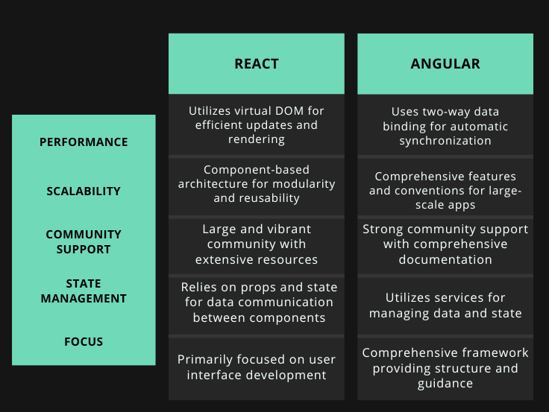
Table 1 A comparative analysis of React and Angular: Key Differences

2.4 Leading Websites and Companies using ReactJS
React has been a popular choice for developing websites and used by large corporations as Meta, Netflix, Uber, Airbnb, The New York Times. Since React was created by Facebook, originally it was only used for the development of the Facebook app and website, but since then other technology giants have benefitted of its usage. Netflix also used React to improve its user interface. For instance, Netflix leveraged React to enhance their platform's usability, while Uber's engineering team utilized React Native's features to develop the Base Web design framework and open-source tools. Airbnb implemented React to help load components onto screens quickly and accurately, and the New York Times said he used a combination of React, GraphQL, and Node, to create a more robust application.

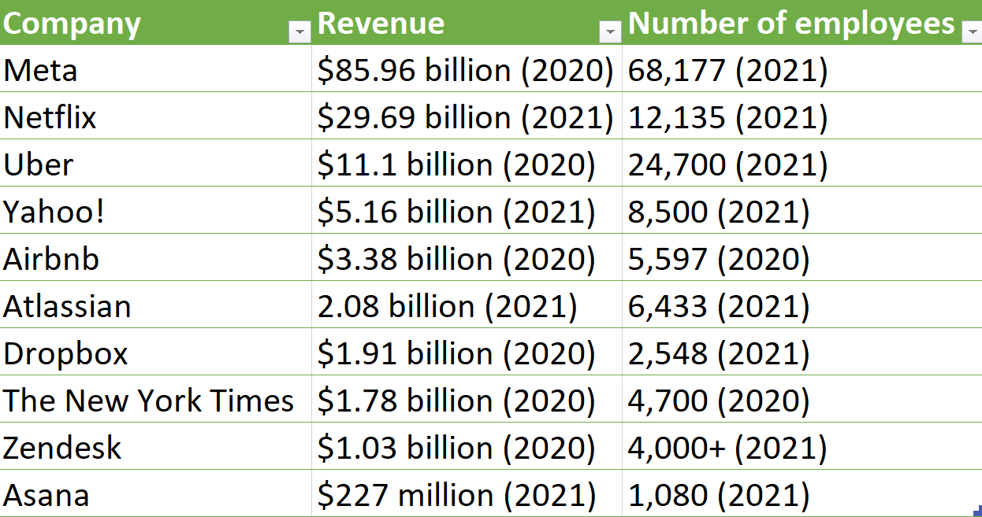
Table 2. Prominent companies embracing React: Revenue and employee statistics, February 12 2022, https://careerkarma.com/blog/companies-that-use-react/, last visited 17/04/2023

2.5 Importance of Design in React JS
In React, design plays a crucial role as it empowers developers to craft user interfaces that are user-friendly, visually captivating, and intuitive. A well-executed design can elevate the user experience, making applications more enjoyable to navigate, while also enhancing overall performance and efficiency.
The implementation of UI/UX design in React typically involves a process of research, planning, and design execution. This process takes place with several key steps:
a) User Research: This involves understanding the target audience, their needs, preferences, and pain points. By gaining insights into user behavior and expectations, developers can make informed design decisions that cater to the user's requirements.
b) Wireframing: After gathering user research, the next step is to create wireframes. Wireframes are basic visual representations of the user interface, outlining the layout, structure, and functionality of the application. They serve as a blueprint for the design and allow developers to visualize the overall flow of the application before diving into the actual implementation.
c) Visual Design: his involves creating the visual elements of the user interface, such as color schemes, typography, icons, and imagery. The design should align with the branding guidelines and aim to create a visually cohesive and appealing interface. Tools like Sketch, Figma, or Adobe XD can be used to create high-fidelity designs.
d) Usability Testing: Once the prototype is ready, usability testing is conducted to gather feedback from users. This involves observing how users interact with the design and identifying any usability issues or areas for improvement. Usability testing helps in refining the design and making it more intuitive and user-friendly.
e) Implementation: After iterating on the design based on user feedback, the final step is to implement the UI/UX design in React. React's component-based architecture facilitates the translation of design elements into code. Developers can use CSS frameworks like Bootstrap or Material-UI to enhance the visual aspects of the components and create responsive designs.
Component libraries offer various benefits to UI/UX design. Firstly, they offer a range of pre-made UI components that are reusable, allowing for rapid and efficient creation of user interfaces. This saves valuable time and effort while ensuring consistent and top-notch designs. Furthermore, these libraries often come with design guidelines and best practices, enabling designers to develop intuitive, user-friendly interfaces that align with the company's branding.

Using Component Libraries in React JS
For beginner React developers who are installing a component library, it is common to question the necessity of using such libraries. However, component libraries serve as valuable assets to applications by ensuring design consistency, ultimately enhancing the user experience. Furthermore, these libraries offer numerous benefits to developers, enabling them to create reusable user interface elements that can be applied in diverse contexts and scenarios. This approach simplifies the construction of complex user interfaces, resulting in cleaner, more efficient, and maintainable code.
Below are better analyzed the advantages of installing a component library in you React application:
• Consistency: Component libraries provide a set of pre-designed, reusable components with consistent styles and behaviors. This ensures a consistent look and feel across different parts of your application, promoting a cohesive user experience.
• Productivity: Developers can focus more on the core logic and functionality of their application, rather than spending time on repetitive UI tasks.
• Code Reusability: Component libraries encourage code reusability by providing a collection of modular components. These components can be shared and reused across different projects, leading to a more efficient development process and reducing the duplication of code.
• Accessibility: Component libraries often prioritize accessibility, ensuring that their components are built with proper semantic markup, keyboard navigation support, and other accessibility best practices. By using these components, you can improve the accessibility of your application without having to build everything from scratch.
• Community Support: Popular component libraries have a large community of developers contributing to their development and maintenance. This means you can benefit from ongoing updates, bug fixes, and new features provided by the community, ensuring that your application stays up to date with the latest trends and improvements.
Overall, component libraries in React.js offer a range of benefits, including consistent UI, increased productivity, code reusability, improved performance, community support, design consistency, accessibility, and easier collaboration. These advantages can significantly enhance the development process and the quality of your React.js applications.

CHAPTER 3

METHODOLOGY

Waterfall model for React component library development
The waterfall model consists on a sequential design process in software development where each phase must be completed before the next phase can begin. The term “waterfall” relates to the processes falling downwards similar to a waterfall.
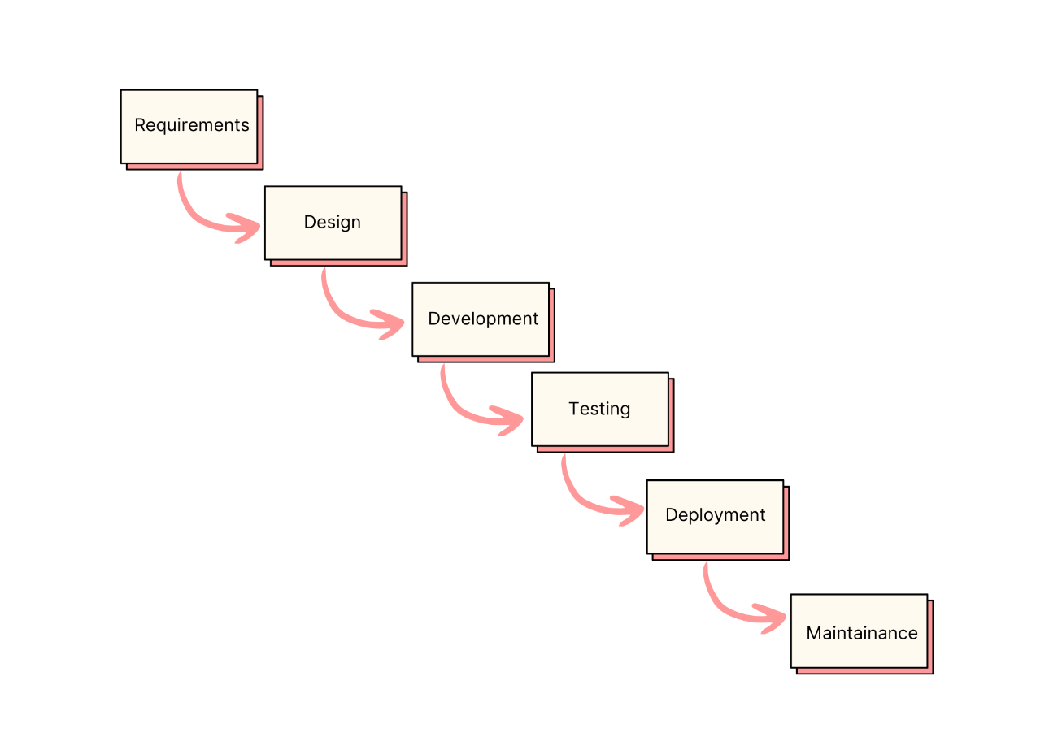
Figure 1. The waterfall model for the development of the React component library.

The waterfall model is made of six sequential phases as illustrated in the image above:
- Requirements
- Design
- Development
- Testing
- Deployment
- Maintenance
During the requirements phase, several steps were taken into consideration. Through research about existing literature on React JS, it was revealed a scarcity literature on developing React component libraries despite its widespread popularity. This highlights the potential to create a valuable resource for developers, since new component libraries are in high demand for use. The scope of the project was to build a credit card form component, with specific and self-contained functionality that can be easily integrated into larger projects. Building the credit card form component involves implementing various features such as form validation, real-time formatting of the card number, expiration date and security code, along with a visually appealing UI/UX design that will attract other developers to use and install the library.
Regarding the design process, the main focus was to create a detailed plan to meet the requirements gathered in the previous phase. The key design considerations included the study of best design patterns and practices to ensure the component is consistent maintainable and scalable, as well as an aesthetically pleasing and intuitive user interface for the component. In addition, it was defined the component architecture including the component hierarchy, communication between components, and how data is passed down to child components. It is important to note that during the design process, Figma mockups were created of the mobile and desktop versions of the credit card form component. These mockups are in help to visualize the layout and user interface design of the component and serve as a reference for the development of the final product.
Moving to the next process, Development phase, the planned architecture and design were implemented using React JS code standards. The process involved the writing of code to create the credit card component, including the logic for form validation, and implementing various UI/UX design elements such as buttons, input fields and labels.
In the testing phase, the key priority is to verify that the component performs as expected. To achieve this, the Jest testing framework is used to rigorously test the component. Additionally, Storybook served as a valuable tool providing an isolated development environment to assess the component's functionality and behavior. Through Storybook, the capabilities of the component are evaluated and tested, ensuring its functioning seamlessly.
In the deployment phase, the React component library is prepared for release and production by building and bundling the code using a build tool as Rollup. The final product will be deployed to a package registry like ‘npm’. Finally, the product can be used in various projects and will come with a manual including its usage, installation and configuration guidelines, to make it easier for developers to use.
To conclude with the last phase, Maintenance phase, is the process of ensuring that the component library remains up-to-date and functional after its initial release. Part of this is to address user feedback and updating the library as per any changes in the React ecosystem.

Components in React JS
To create a component library, it is crucial to thoroughly examine the conceptual design of each component. In this paper, we will analyze these steps specifically for the credit card form component being developed.
Purpose:
Identifying the purpose of a component entails recognizing its role within the overall user interface. This includes determining the needs it addresses and the objectives it helps achieve. The purpose of the credit card form component is to provide users with convenient ways to input their credit card information. This component will be used in e-commerce websites, and applications where users will need to make payments using a credit card. The goals of the component are to provide user friendly interfaces that will simplify the input of credit card information.
Behavior:
Defining the behavior consists on specifying the component function and behaviour within the user interface. The credit card component will support the input of credit card information such as card number, expiration date and CVV code. A real time validation of the input data will be done so that it ensures there are not any errors in it. The component will be designed to be responsive to different device sizes and input methods.
Structure:
Determining the structure includes the internal structure and organization of the component.
The credit card component involves several child components as input fields for the input data of the credit card: card number, expiration date and CVV code, as well as labels and buttons.
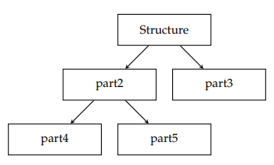
Figure 2. Hierarchy of structural elements in UIML, showcasing the organization and relationships among different components for creating user interfaces

Designing the Credit Card Component in Figma
To improve the visualization of the credit card form component and to meet the second step of the waterfall model proposed for this thesis, I used the power of Figma, a web-based design tool to define the component’s appearance and layout. Figma is a web application used for interface design and focused on user interface and user experience design (UI/UX) making use of a variety of vector graphics editor and prototyping tools.
Specifically, for the credit card components, I designed several mockups for different use cases and screen sizes. To begin with, appropriate fonts and colors were chosen based on their suitability and relevance for this case study. The fonts chosen were the fonts: Jura, Karla and Inter. The fonts Jura and Karla were chosen as a better fit for the design of the credit card, whereas the Inter font is a standard font used throughout web-applications and applications. The colors found better suited for this component are shown below:
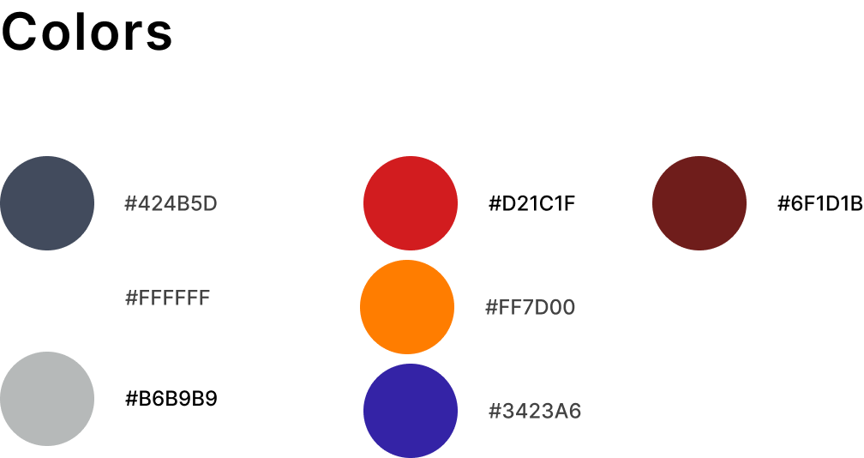
Figure 3. Colors used in the Figma mockups of the credit card form component
The choice of colors has a significant impact on the user experience and that is what this choice is based on. For example, the dark blue color (#3423A6) is associated with trust, security and stability, which are qualities that are crucial when filling a credit card component. Red (as in #D21C1F) is used to convey a sense of urgency and is helpful in drawing attention to the user’s attention. As for the orange (#FF7D00), it is often associated with excitement which is also used for drawing attention to interactive elements such as buttons. The other colors used in these mockups are carefully chosen to create a visually appealing design.
Next, I created various iterations of the credit card design to determine the best fit for the component. Specifically, I designed two versions of the credit card component for the two most commonly used credit cards, MasterCard and Visa. The goal was to differentiate the design of these two types of cards while maintaining a cohesive and consistent component identity. 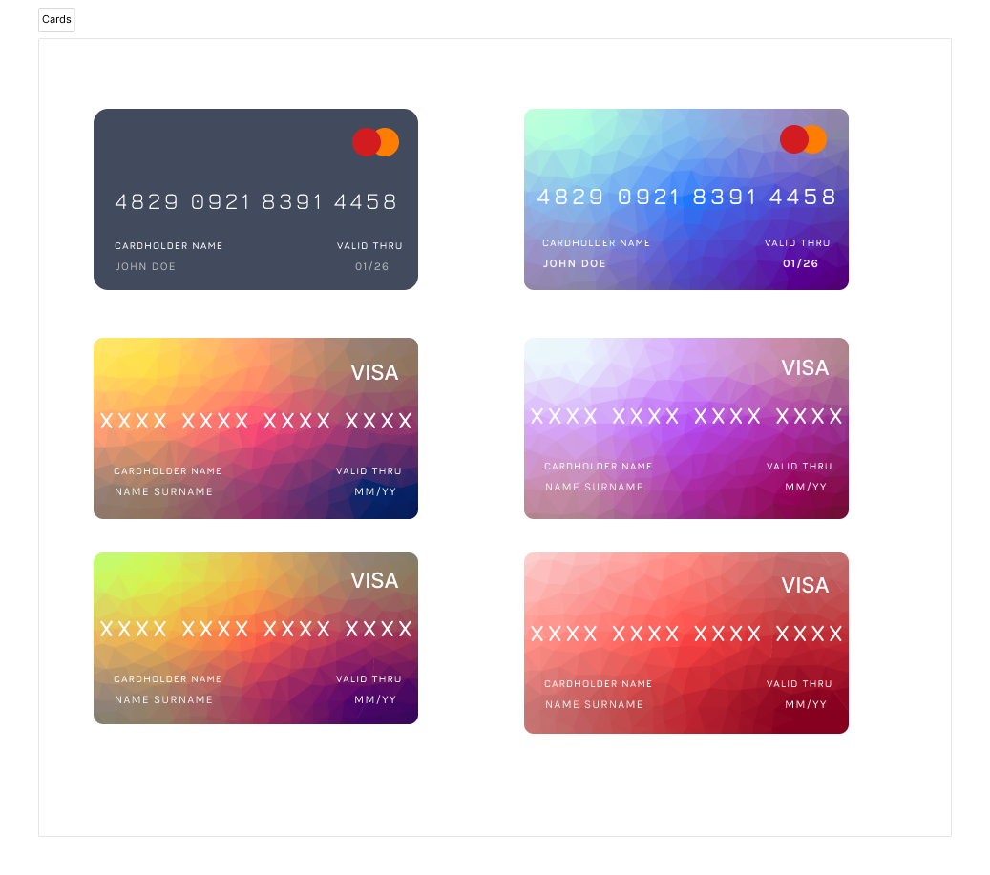
Figure 4. Variation of Credit Cards (MasterCard and Visa)
Finally, for the complete mockup of the credit card form component, I have created mobile versions of the credit card design for both Mastercard and Visa Credit Card. Below are the mockups for each credit card type in their respective mobile versions.
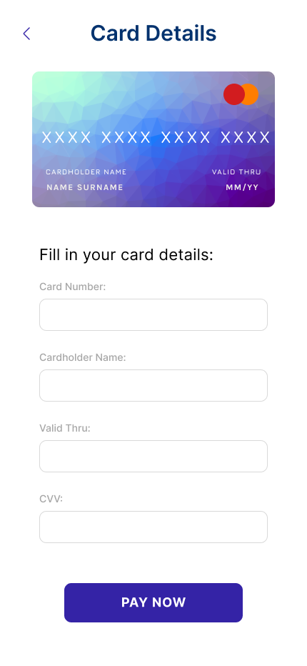
Figure 5. MasterCard Credit Card Form Component Mockup, iPhone 14 Pro Max - 1: Empty Fields

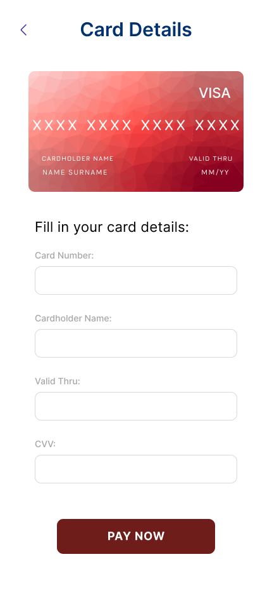
Figure 6. Visa Credit Card Form Component Mockup, iPhone 14 Pro Max - 1: Empty Fields

The following demonstrates how the credit card design dynamically updates based on the user input in the input fields. As the user fills out the input fields with credit card data, the card design displayed above the input fields reflects the information inputted, providing the user with real-time feedback on their input.
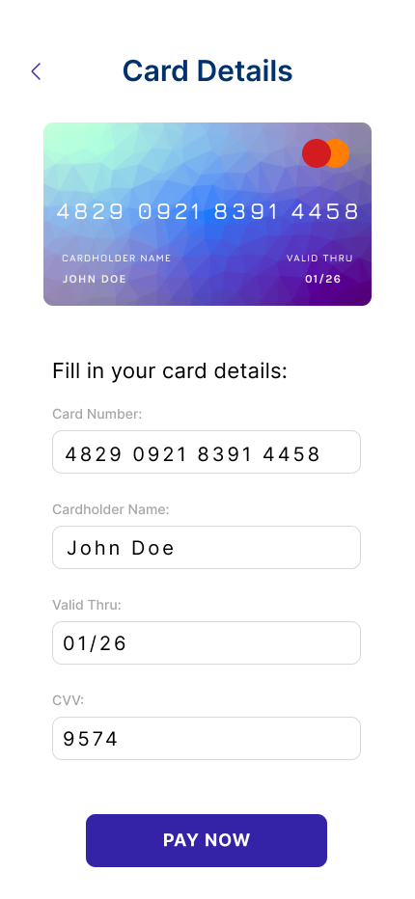
Figure 7. MasterCard Credit Card Form Component Mockup, iPhone 14 Pro Max - 1: Completed Fields

In addition to the mobile design, a desktop version of the credit card form component was also created. The credit card form is shown more clearly and allows for more detailed user input on the desktop version. Regardless of the device being used, users can easily enter their credit card information due to the desktop version's improved style and design, which guarantees a flawless user experience.
The desktop version includes dynamic updating of the credit card design based on user input, just like the mobile design does. In addition to offering a visually appealing experience, this functionality enables users to quickly verify the integrity of the data they have submitted.
Overall, by designing both a mobile and desktop version of the credit card form component, the user experience is improved and ensures that users can easily interact with the component regardless of the device they are using.
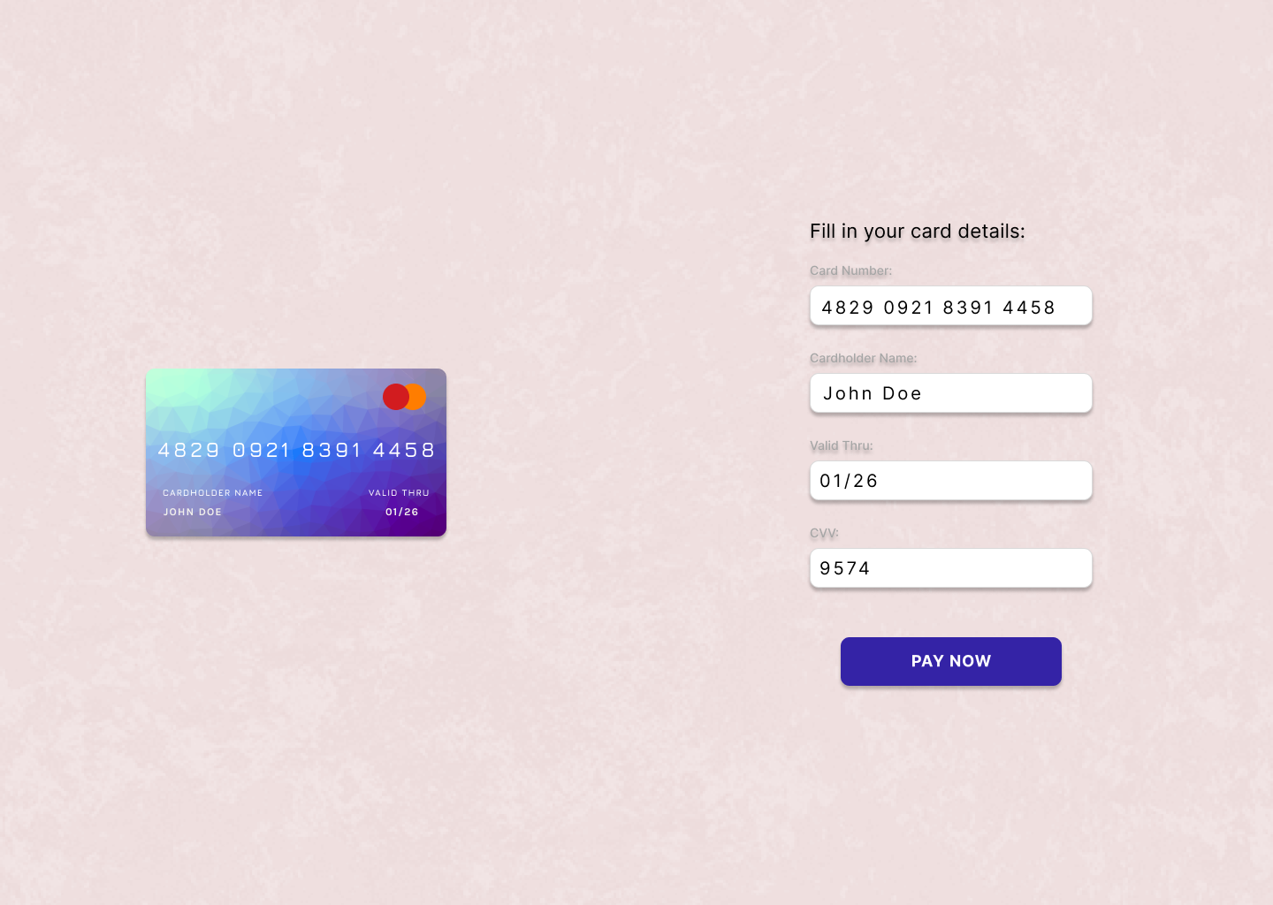
Figure 8. MasterCard Credit Card Form Component Mockup, Desktop: Completed Fields

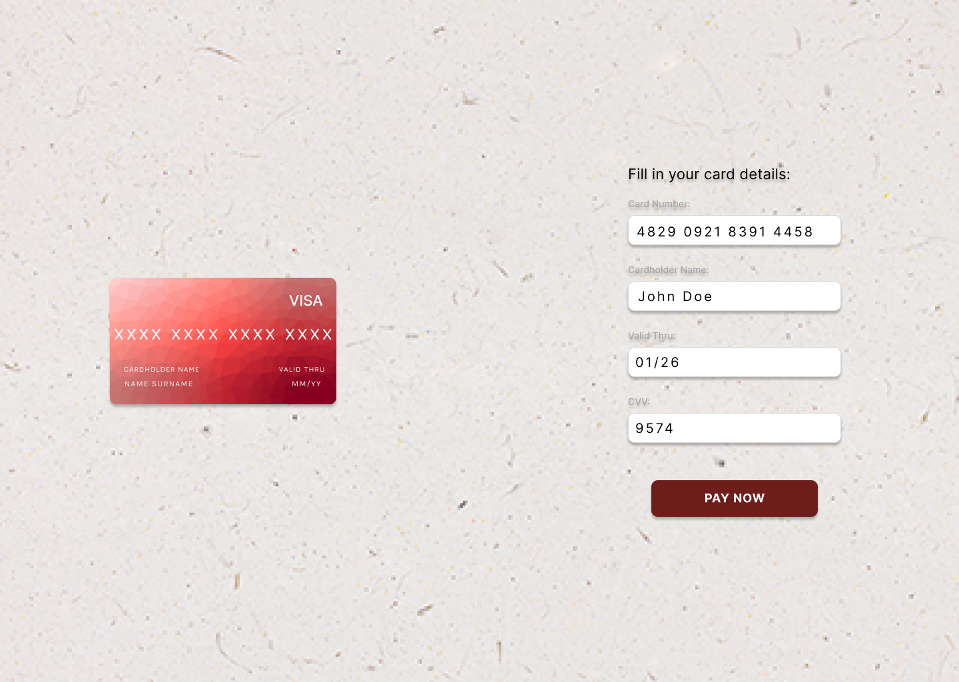
Figure 9. Visa Credit Card Form Component Mockup, Desktop: Completed Fields

CSS Styling for React Components
Styling is a principal aspect of creating visually appealing user interfaces in React component development. This section will explore different approaches and best practices for styling React components using CSS. Styling React components can be done with various approaches, ranging from inline styles to CSS modules and CSS-in-JS libraries. Inline styles allow for directly defining styles within the component, providing encapsulation and reducing style conflicts. CSS modules offer the ability to scope styles locally to specific components, ensuring modularity and preventing unintended side effects. CSS-in-JS libraries, on the other hand, enable developers to write styles directly within JavaScript code, promoting component-based styling and dynamic styles.
To style the CreditCardForm component, a dedicated CSS file named CreditCardForm.css was created within the CreditCardForm directory.
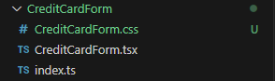
Figure 10. CreditCardForm directory showing the addition of the CreditCardForm.css file for styling the CreditCardForm component.

This CSS file was then imported into the CreditCardForm.tsx file using the import statement: import "./CreditCardForm.css".
To process the CSS syntax during the build process, a rollup-plugin-postcss was utilized. The plugin was installed by running the following command: npm install rollup-plugin-postcss --save-dev. Furthermore, the rollup configuration needed to be updated to include the postcss plugin.

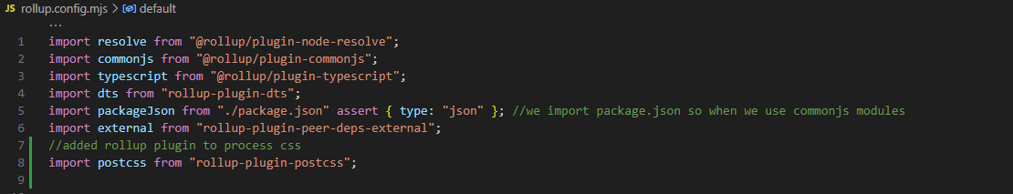
Figure 11. Modification of the rollup configuration file, where the rollup-plugin-postcss is imported as a plugin to process CSS styles for the CreditCardForm component.

This was achieved by adding postcss() to the plugins array.
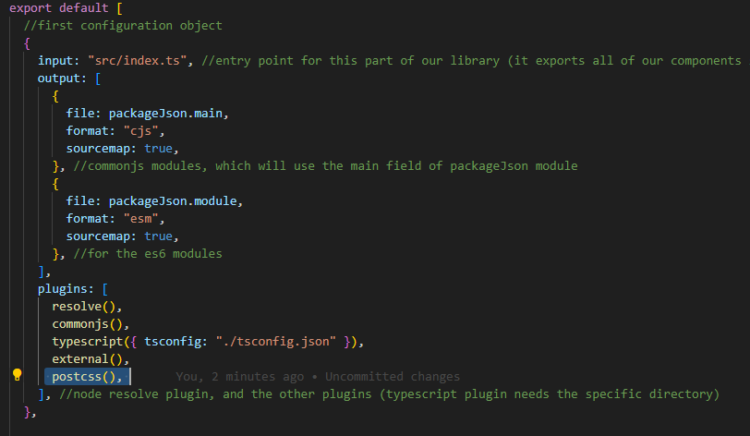
Figure 12. Modification of the rollup configuration file, where the postcss() is added as a plugin in the first configuration object for the CreditCardForm component

Additionally, the CSS file needed to be marked as an external dependency within the rollup configuration by including external: [/\.css$/] in the configuration object. These steps ensured that the CSS styles in the CreditCardForm component were properly processed and applied during the build process.
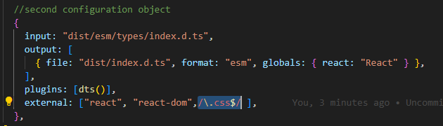
Figure 13. Modification of the rollup configuration file, where : [/\.css$/] is added in the second configuration object as an external for the CreditCardForm component

In order to import images effectively in a React component library, a few steps need to be followed. First, a custom.d.ts file in the src directory of the project is created. This file serves the purpose of augmenting the module system to recognize non-JavaScript files, such as images. Within the custom.d.ts file, the code shown in the below screenshot is needed, which declares modules for different image file extensions like .jpg, .png, .jpeg, .svg, .gif, and .ico.
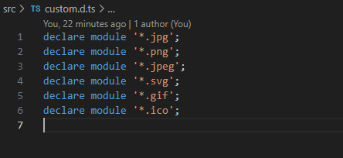
Figure 14. Custom.d.ts file in the src directory, demonstrating the module augmentation for recognizing non-JavaScript files, including images.

Additionally, to handle non-JavaScript files, including images, within the library, it is necessary to install the 'rollup-plugin-url' plugin. This plugin allows Rollup, the module bundler, to handle and process non-JavaScript files. For the installation of this plugin, it is used this command: 'npm install rollup-plugin-url'. After installing the plugin, the rollup configuration file needs to updated, as depicted in the screenshot below. This involves adding the 'rollup-plugin-url' to the list of plugins used in the configuration.

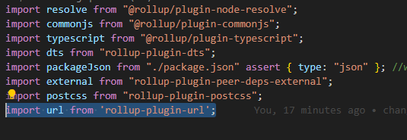
Figure 15. Addition of 'rollup-plugin-url' to the rollup configuration file, enabling handling and processing of non-JavaScript files, such as images, during the build process.

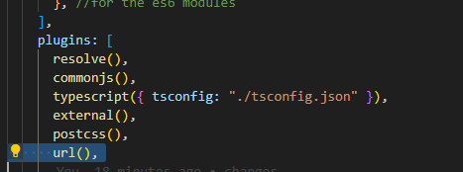
Figure 16. Addition of url plugin to the configuration object in the rollup configuration file

By following these steps, images can be imported seamlessly in the React component library. The custom.d.ts file ensures that image imports are recognized by the module system, while the 'rollup-plugin-url' plugin facilitates the handling of non-JavaScript files, such as images, during the build process.

Semantic Versioning for React Components

Semantic versioning is important for managing the development, maintenance, and compatibility of React component libraries. Semantic versioning provides a standardized approach to versioning software components. It addresses the challenges of managing changes, communicating compatibility, and handling dependencies between software projects. By following semantic versioning principles, developers can ensure that updates and modifications to libraries are easily understood and properly integrated.
Semantic versioning follows a three-part versioning scheme: MAJOR, MINOR and PATCH. Each component represents a different type of change:
- MAJOR version increment indicates incompatible API changes.
- MINOR version increment signifies the addition of backward-compatible features.
- PATCH version increment denotes backward-compatible bug fixes or patches.
Understanding the different release types is essential when applying semantic versioning to React component libraries. Major, minor, and patch releases have specific implications for compatibility and expectations:
- Major releases (1.x.x to 2.x.x) indicate significant changes that might require modifications in consumer code.
- Minor releases (1.1.x to 1.2.x) introduce new features or enhancements without breaking existing functionality.
- Patch releases (1.1.1 to 1.1.2) include bug fixes or minor updates that do not introduce new features or breaking changes.
Maintainers must include thorough release notes or changelogs that list all updates that might call for modifying consumer code. This helps users in comprehending the effects of changes and appropriately planning their migration procedure.
In conclusion, maintaining React component libraries effectively requires the use of semantic versioning. By following to this versioning system, library maintainers can manage compatibility, provide clear communication, and give users the power to choose updates wisely. Both library users and maintainers must have a thorough understanding of the fundamentals and best practices of semantic versioning.

Testing React Components
In modern software development, testing plays a significant role in ensuring the quality, reliability, and maintainability of software components. Testing is an essential practice in software development that offers numerous benefits. When applied to React components, testing allows developers to identify and rectify issues early in the development cycle, resulting in improved code quality. By writing tests, developers can detect and fix bugs, prevent regressions, and ensure that the components function as intended.
In React component development, various types of tests are commonly employed to cover different aspects of functionality and behavior. These include:
- Unit tests: These tests focus on individual components or functions in isolation, verifying their correctness and ensuring that they behave as expected.
- Integration tests: Integration tests examine the interactions and dependencies between multiple components, verifying that they work together correctly.
- End-to-end tests: These tests simulate user interactions and test the application as a whole, including React components, backend services, and external dependencies.
To facilitate testing in React component development, there are several popular testing frameworks and libraries. These frameworks provide a set of tools and utilities to write and execute tests effectively. Some examples include:
Jest: Jest is a widely used testing framework that offers a comprehensive suite of testing utilities, including mocking, assertions, and test runners. It provides a simple and intuitive API for writing tests and is known for its speed and ease of use.
React Testing Library: React Testing Library focuses on testing React components in a way that closely resembles how users interact with them. It encourages testing from the user's perspective, promoting more reliable and maintainable tests.
Enzyme: Enzyme is a testing utility specifically designed for React components. It provides a set of powerful APIs to traverse, manipulate, and assert on React components' output. Enzyme simplifies the process of testing component rendering, state changes, and event handling.
For my specific React component library, the Credit Card Form component, I have utilized these testing frameworks and tools. To execute the tests, the following steps were performed:
- Running the tests using the command: `npm run test`.
It's important to note that Jest no longer includes `jsdom` by default as the test environment. To use the test environment, the `jest-environment-jsdom` package needs to be downloaded as a dev dependency separately.
- Installing `jest-environment-jsdom` as a dev dependency by executing the command: `npm install jest-environment-jsdom --save-dev`.
- A configuration file named jest.config.js was created containing the configuration of the test environment, and the moduleNameMapper that specifies module name mapping for module imports.
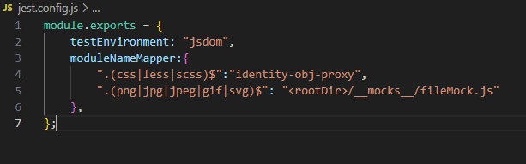
Figure 17. A visualization of the jest.config.js file in the root directory of the project.
In addition, a __mocks__ folder is created in the root directory of the project, which contains a file named ‘fileMock.js’ as shown in the screenshot below. In the `fileMock.js` file, the line `module.exports = 'test-file-stub';` is exporting a string value `'test-file-stub'` as the module's default export.
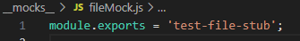
Figure 18. Module Exports of fileMock.js
In Jest, when you define a mock for a file import, it is needed to provide a mock implementation that can be used in place of the actual file. In this case, the mock implementation is a simple string value.
When an image file is imported in the Jest tests, instead of loading the actual image file, Jest will load this mock module (`fileMock.js`) and use the exported value `'test-file-stub'` as a replacement for the image file.
By following these steps, the Credit Card Form component was thoroughly tested using the Jest framework in a suitable testing environment, ensuring its functionality and adherence to requirements. To run tests using Jests, a test file is created in the directory of CreditCardForm named ‘CreditCardForm.test.jsx’ where are located all the tests created for testing the Credit Card form component. In order to run the tests, a command is run: ‘npm run jest’.
In conclusion, testing React components is important to ensure software quality and reliability. By understanding the different types of tests and utilizing appropriate testing frameworks and tools like Jest, React Testing Library, and Enzyme, developers can create robust and dependable React component libraries. Through the execution of tests for the Credit Card Form component, including the installation of `jest-environment-jsdom` as a dev dependency, comprehensive testing has been conducted to ensure the reliability and proper functioning of the component within the React ecosystem.

Configuring Babel library in React JS
Babel is a popular JavaScript compiler whose main purpose is to convert ECMAScript 2015+ code into backwards compatible version of JavaScript while still supporting older web browsers and environments. Thus, it is important for a component library to have installed these Babel packages, for the library to be compatible with a wide range of environments and can easily be used by other developers. In the Credit Card Form Component library, the following babel packages are installed:
- npm install @babel/core @babel/preset-env @babel/preset-react @babel/preset-typescript
With these packages, there are several benefits gained such as: support for latest JavaScript features as arrow functions or object destructuring, JSX transformation (where it is possible to read HTML code in JavaScript files) and TypeScript transformation which helps Babel parse and transform TypeScript code, if the component library includes some.
By including these Babel packages in the component library, we ensure that the library can be used by developers who might have different versions of JavaScript, browser requirements, or usage of TypeScript.

Object Proxy and Module Name Mapper

When designing and implementing a component library in React.js, Object Proxy and Module Name Mapper are two very important concepts. Object Proxy is a JavaScript feature that makes possible to intercept and customize fundamental operations on objects such as property access, function invocations etc. By using it, powerful mechanisms for object manipulation, validation and encapsulation can be implemented. More specifically, in the Credit Card Form Component, object proxy is used to enhance the functionality and behavior of it. By intercepting certain operations on the form's data object, we were able to implement advanced validation logic, perform automatic formatting of input values, and enforce specific constraints on user input.
Regarding Module Name Mapper, it is a configuration option commonly found in module bundler and testing frameworks. Its function is to allow developers define custom mappings for module imports and enabling them to handle non JavaScript imports, such as CSS files or image assets.
In the Credit Card Form Component Library, module name mapper was used to incorporate CSS stylesheets and handle image file imports within the Jest tests created. In order to achieve this, moduleNameMapper was configured in the Jest configuration file as shown in the previous section. For CSS imports, the ‘identity-obj-proxy’ was used as a mapping, which acted as a mock for CSS modules for the Jest tests. Similarly, was done about image file imports. By utilizing Module Name Mapper and the appropriate mock files, the tests of the Credit Card Form Component were done comprehensively, ensuring that CSS styles were applied correctly and image assets were handled without any issues. These tests will be available in the end of this paper.
Overall, the integration of Object Proxy and Module Name Mapper played vital roles in the design and implementation of our component library, specifically in the development of the Credit Card Form Component. These concepts provided us with powerful mechanisms for data manipulation and seamless handling of non-JavaScript imports, ultimately contributing to the usability, functionality, and testability of our component library.

Introduction to Storybook and building storybook for react components
Storybook is an open-source tool that allows developers to build and showcase interactive UI components in an isolated and visually appealing manner. It provides a development environment where you can create, browse, and test your components independently of your application's business logic.
With Storybook, you can create "stories" for your components, representing different states, use cases, or variations of your UI elements. These stories act as individual units of demonstration, enabling you to visualize and interact with your components in different scenarios.
To start building a Storybook for the Credit Card Form component, a straightforward setup process was followed. By running the following commands:
- npx sb init: This command initializes a new Storybook project in our component library. It sets up the necessary configuration files and creates a directory called "stories" to house our component stories.
- npm run storybook: This command runs Storybook, launching it in its default port. It compiles and displays our component stories, allowing us to view and interact with them in a dedicated Storybook environment.

Upon executing these commands, a new directory called "stories" was created in our project structure. Additionally, within the "CreditCardForm" directory, we created a file named "CreditCardForm.stories.tsx." This file served as the entry point for creating stories specific to our Credit Card Form Component. In "CreditCardForm.stories.tsx," we defined several stories that showcased different scenarios, states, or variations of the Credit Card Form Component. Each story consisted of a set of props or data specific to that scenario, allowing us to visualize the component with various input values, error states, or styling variations. With the command 'npm run storybook', Storybook launched in its dedicated port. We were able to browse our component stories and visually interact with them. This allowed us to assess the appearance, behavior, and functionality of our components in a controlled environment, separate from our main application. By leveraging Storybook, we gained the ability to develop and refine our components in isolation. It provided an efficient workflow for rapid prototyping, visual testing, and collaboration within our development team.
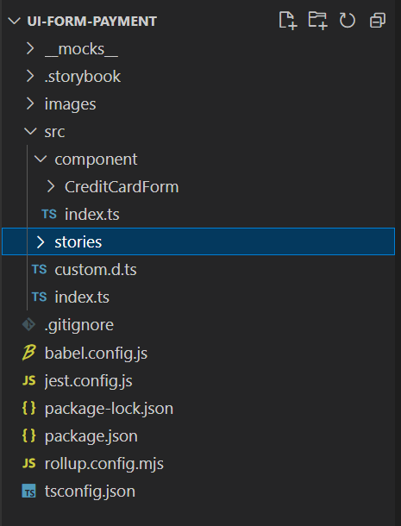
Figure 19. Screenshot showcasing the creation of the 'stories' folder, a dedicated space for building and organizing component stories in our React component library.
Storybook proved to be an invaluable tool in the development of our component library. Its ability to showcase and interact with React components in isolation greatly facilitated our design process, allowing us to iterate, refine, and test our components effectively.

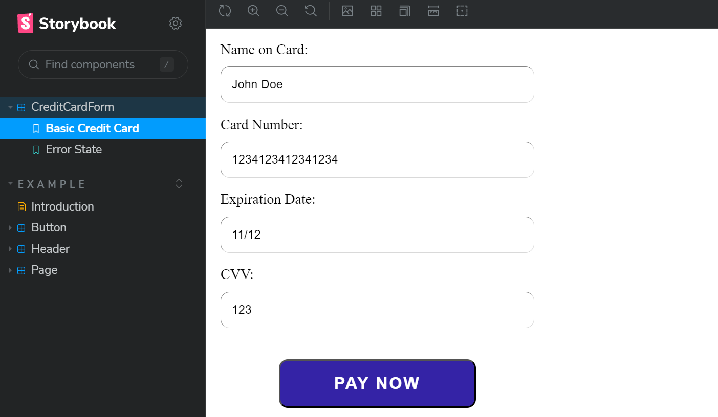
Figure 20. Screenshot of Storybook displaying a scenario in which every input field in the Credit Card Form Component is valid, providing a clear and consistent user interface.

CHAPTER 4

RESULTS AND DISCUSSION

Implementing a Credit Card Form Component
Creating a component library requires the utilization of an IDE. An IDE is an Integrated Development Environment compiler which facilitates the process of software development. There are numerous advantages in using an IDE compiler such as offering tools and extensions that help your journey with development and coding, debugging, or testing. Additionally, a compiler can seamlessly integrate with various other software development tools, such as version control systems, enabling a streamlined and reliable development workflow. In this library, Visual Studio Code was used to for the development, and its specific configuration are as the following:
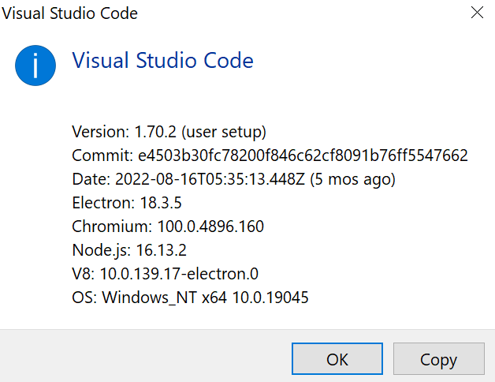
Figure 21. A screenshot of the IDE compiler used, Visual Studio Code configurations
For the implementation of the component library, I followed a series of steps. Initially, using the Command Prompt to create a new directory dedicated to this purpose. Next, I opened this newly created directory in Visual Studio Code. Subsequently, I proceeded to initialize a new project by installing the necessary npm packages. This was accomplished by executing the command 'npm init'. In Node.js, the 'npm init' command is employed to create a package.json file, which serves as a vital component in Node.js projects. This file contains essential project information such as its name, version, dependencies, and scripts. The 'npm init' command generates a basic package.json file that can be further modified and customized as per requirements. When executing 'npm init', an interactive prompt appears, requesting details about the project. Based on the provided input, a package.json file is generated. This file acts as a project manifest, aiding other developers in understanding its structure and dependencies.
Initially, the package.json file generated by the 'npm init' command can be used with its default configurations. However, as development advances, additional configurations can be incorporated as needed. o maintain a well-structured and organized project, new directories were created within the main project directory. The accompanying illustration illustrates the creation of a 'src' directory, serving as the source folder. Within the source folder, specific directories were established, including one exclusively dedicated to the development of the credit card component.

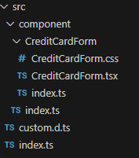
Figure 22. Illustration of the initial structure of the directory for the Credit Card Component

Within the Credit Card Form file, is imported the react library which enables the construction of a user interface in React. To be able to import react, firstly it is needed to be installed in our project. For its installation, the following command was executed: npm install react typescript @types/react --save-dev.
The CreditCardFormprops interface specifies the required properties, also known as "props," for the component. The specific props required by the component are as shown on the picture below:
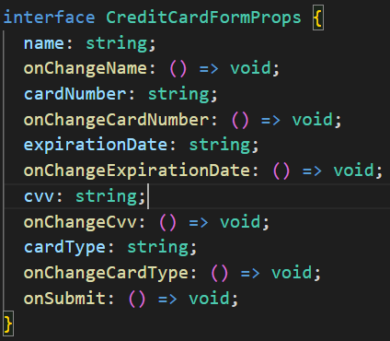
Figure 23. Screenshot of the CreditCardForm props used to create its interface
The Credit Card Form file is made of a functional component, which takes the Credit Card Form Props as an argument. These props are responsible for defining the components interface.
The component returns a section divided into two main parts: a "card-container" and a "form-container". In the "card-container" section, it renders a representation of a credit card. It includes the card type logo (in this case, the Mastercard logo), the card number, the cardholder's name, and the card's expiration date. In the "form-container" section, it displays a heading "Fill in your card details" followed by a form for inputting card information. The form includes input fields for the cardholder's name, card number, expiration date, and CVV (Card Verification Value). Each input field is accompanied by a corresponding label and includes validation attributes such as required, pattern, minLength, maxLength, and title. At the end of the form, there is a "Pay now" button to submit the form.
Overall, this component represents a credit card form that allows users to input their card details for payment processing. The "card-container" visually represents a sample credit card, while the "form-container" contains the necessary input fields and validation for capturing the required card information.
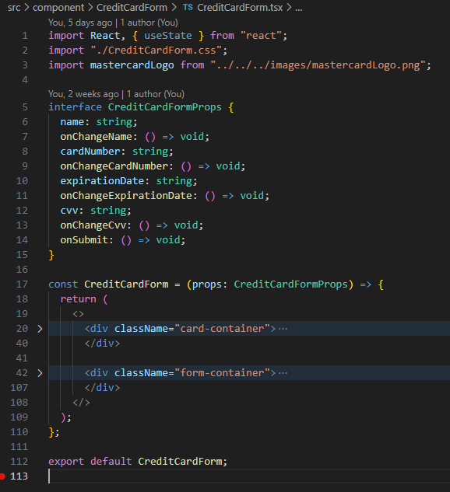
Figure 24.React Credit Card Form Component, in the file CreditCardComponent.tsx
In the following picture (Figure 25), is shown the way the component is exported from its own directory. This ensures that the component can be accessed and utilized within that specific directory.
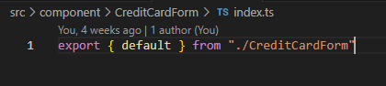
Figure 25. The code to export the Credit Card form Component from the Credit Card form’s directory
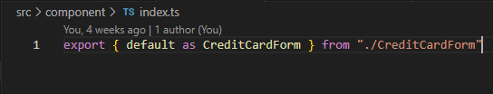
Figure 26 Screenshot that shows the process of exporting the Credit Card form component from the components directory
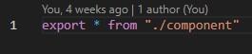
Figure 27. Illustration of the export of the component for others to conveniently import and integrate into their respective projects.

Configuring TypeScript in the Credit Card Form Component
To create a TypeScript configuration file (tsconfig.json) for the project, we employ the command npx tsc --init. This file enables us to define various compiler options for TypeScript, including the target JavaScript version and the source directory, among others. The usage of the "npx" command allows the execution of a package, in this case, the TypeScript compiler, without the need for a global installation. Although tsconfig.json initially includes default configurations, additional project-specific configurations are necessary, as depicted in Figure 28.
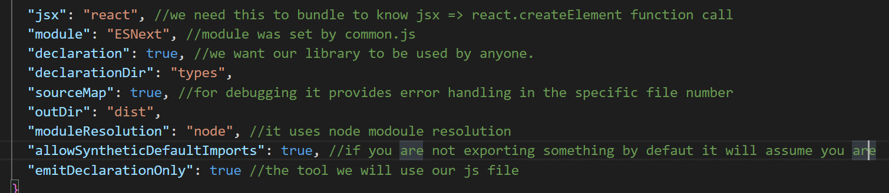
Figure 28. Visual screenshot of the tsconfi.json file with the modifications required to prepare the project
The configurations done in the tsconfig.json file come in help for defining the options the compiler has to read for TypeScript. As described in the comments in the code (Figure 28), these configuration help in interpreting JSX syntax as React, •adopting the ESNext module format., generating declaration files and storing them in the types directory, generating source maps to facilitate debugging, gives a roadmap to output the compiled file into the dist, etc.

Configuring Rollup for a Component Library and Key Files for Rollup Configuration in a React Component Library
Rollup is a JavaScript module bundler that combines various modules of an application into an optimized bundle. Then, this bundled file is loaded by a browser, resulting in improved load times and reduced network requests.
When it comes to component libraries, Rollup proves useful for creating individual standalone bundles for each component. This allows the distribution of components as a unified package that can be effortlessly imported and used in other projects. Rollup helps in removing unused code from the final bundle and it reduces its size.
To configure Rollup in our component library, it was needed to install several rollup plugins. Firstly rollup was installed which is the module bundler responsible for the combination of modules and it was installed with the respective command ‘npm install rollup . Then the plugin node resolve was installed, which aims the resolving of modules within the environment which is Node.js, the plugin was installed with the command @rollup/plugin-node-resolve . The next plugin installed is named commonjs, which converts commonjs modules into ES6 modules and it is installed with the command @rollup/plugin-commonjs. Another plugin installed is the one which compiles all the typescript files into javascript ones and it is executed with this command @rollup/plugin-typescript. The last plugin installed is the one with the command: rollup-plugin-dts’, which generates TypeScript declaration files from the bundled JavaScript. All of these commands were accompanied with the ‘ –save-dev’, since they are specified as development packages, meaning that they are needed only for the building of the project and not responsible for running it.
After installing these plugins, for the bundling with rollup to be done correctly, a ‘rollup.config.mjs’ file is needed to set up properly. Below is shown a screenshot illustrating what this file looks like:
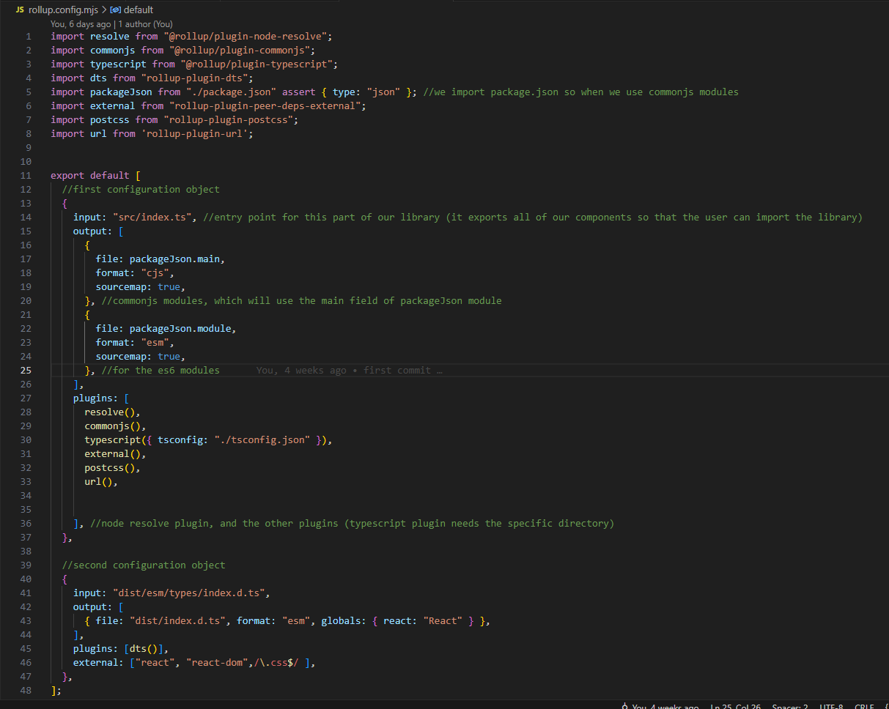
Figure 29. Illustration of th Rollup configurations created concerning the plugins installed

The provided code establishes the input and output files, along with the imported Rollup plugins such as resolve, commonjs, typescript, and dts. Additionally, it specifies the output file format as ECMAScript modules and enables the generation of sourcemaps. The "src/index.ts" file serves as the input, while the "main" and "module" properties in the "package.json" file determine the output file locations. By utilizing the Rollup plugins, the input file undergoes processing to produce the output files in the designated format.
Additionally,’ package.json’ is imported too, since it has project-related information.
When bundling the project with rollup, a distribution directory is created. Once the rollup configuration file is ready with all of the plugins installed, the command ‘npm run rollup’ can be executed. Subsequently, it is seen to be created a dist directory which includes the modules ES6, Common.js and an index file.

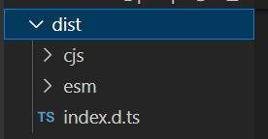
Figure 30 Illuustration of the directory dist which was created after bundling the project with ‘npm run rollup' command.
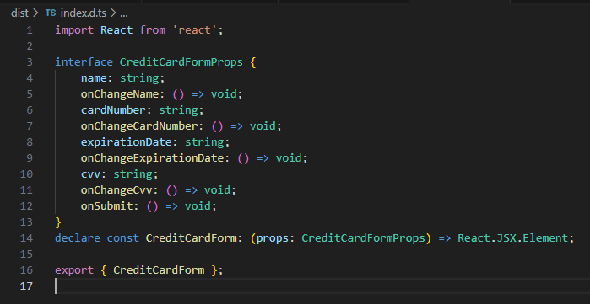
Figure 31. Illustration that displays the interface of the Credit Card component along with the associated required data types.

A Comprehensive guide to publishing the React Component Library from Repository to Library launch
Publishing a component library consists on some steps, where creating a GitHub repository is the first one. To this instance, the name is "ui-form-payment" and is set to be public visibility. To offer a description for the repository created, a Read me file was added.
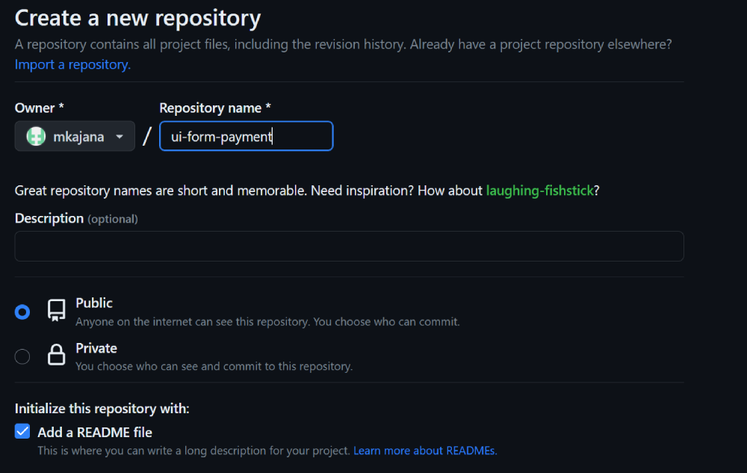
Figure 32. Creating a repository for the component created as part of this thesis was depicted in a screenshot.

The 'git init' command was used to create a new Git repository on the local machine after the repository had been established. A.gitignore file was then added to define the files that ought to be kept out of the repository. This file's goal is to remove pointless information, and to do this removal node_modules and dist, were added in the.gitignore file for this project to keep specific folders out of the Git repository. The following action involved running the command "git add," which added each project file to the Git repository.
The 'git commit -m'my first commit'' command was used to add the adjustments to the repository. The command "git remote add origin repository URL>" was then used to send the code to the remote repository on GitHub. This command added the remote repository's location as the local repository's origin remote and specified its location. The command "git push -u origin master" was then used to push the modifications to the local Git repository.
The upstream branch was set up using the -u option, where was the local branch was connected to the matching remote branch on GitHub. Once the credit-card-form repository was securely hosted on GitHub, the next step involved finalizing the publish process for the React component. It was imperative to create an npm account on the official npm website to proceed. In anticipation of this, I had already created an npm account, which enabled me to seamlessly continue with the subsequent procedures. To authenticate my npmjs account, I utilized the command "npm login" within the Visual Studio Code terminal.
Upon successful login, I proceeded to build the library by executing the "npm run rollup" command. With the necessary preparations in place, I initiated the publication process by running the command "npm publish --access public" within the Visual Studio Code terminal, while positioned in the root project directory. Furthermore, it is important to note that this publish process serves as a standard procedure for future versions of the component library as well. Whenever a new version is ready to be published, the process involves building the library using Rollup and subsequently executing the "npm publish" command. By following this consistent approach, any updates or improvements to the component library can be effectively distributed and made available to other developers and users.
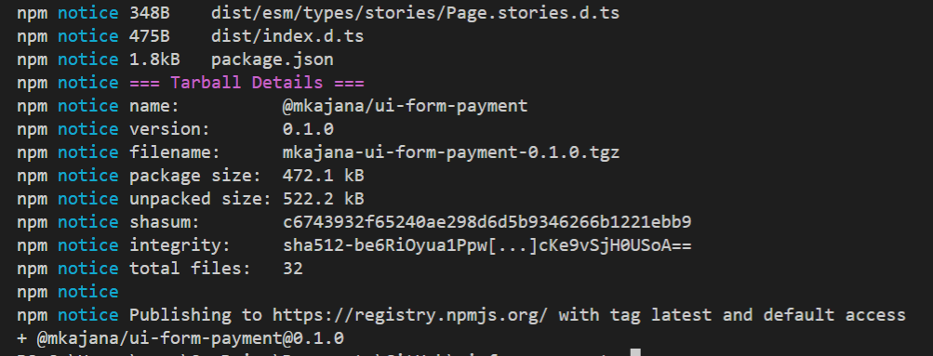
Figure 33. Successfully executed the publishment of @mkajana/ui-form-payment

Comparison of other credit card components and “ui-form-payment” Credit Card Component library
This section includes a comparison between two prominent credit card component libraries: "ui-form-payment" and "react-credit-cards." The focus of this comparison is to analyze the strengths and contributions of "ui-form-payment" while providing constructive recommendations for its future enhancement. By assessing key aspects such as functionality, integration, UI/UX, security, performance, community support, and cost-effectiveness, the comparison gains insights into the distinct advantages of each library and identifies opportunities for refinement. As the author of "ui-form-payment," this evaluation maintains an impartial perspective to present a fair and balanced analysis, ultimately promoting the library's continuous growth and its position as a valuable resource for developers seeking a reliable credit card processing solution.
Functionality:
Both "react-credit-cards" and "ui-form-payment" credit card component libraries offer essential functionalities for credit card visualization and form input.
"react-credit-cards" includes card type detection, automatically updating the card visuals based on the entered card number, providing a seamless user experience.
Future Recommendation for "ui-form-payment": Considering implementing card type detection in "ui-form-payment" to enhance the user experience and provide real-time card visualization based on the input card number.
Integration:
Both libraries are designed for easy integration into React-based projects, ensuring developers can effortlessly incorporate the credit card components into their applications.
"react-credit-cards" provides comprehensive documentation and extensive usage examples, simplifying the integration process for developers.
Future Recommendation for "ui-form-payment": To further facilitate integration, more detailed usage examples and comprehensive documentation will be provided, allowing developers to quickly grasp and utilize the library's capabilities.
UI/UX:
Both "react-credit-cards" and "ui-form-payment" offer visually appealing credit card representations, enhancing the overall user experience during the payment process.
"react-credit-cards" boasts a broader selection of card styles, providing users with more customization options for their applications.
Future Recommendation for "ui-form-payment": To enhance the UI/UX, it will be considered the expanding of the available card styles or providing customization options, allowing developers to tailor the card visualization to match their application's aesthetics.
Security:
The security of credit card components depends on how credit card data is handled and processed within the application using the library.
Both libraries should prioritize security measures to safeguard sensitive credit card information and adhere to industry best practices.
Future Recommendation for "ui-form-payment": To strengthen security, it will be conducted a thorough security audit and ensure that sensitive credit card data is handled securely. Detailed documentation will be provided on the library's security practices to instill confidence in developers and users alike.
Performance:
The performance of the libraries largely depends on their implementation and rendering efficiency.
"react-credit-cards," being an established library, may have undergone more performance optimizations over time.
Future Recommendation for "ui-form-payment": To optimize performance, comprehensive performance tests will be done and areas for improvement will be identified. In addition, performance optimizations will be implemented to ensure efficient rendering and updates, ensuring a smooth user experience.
Support and Updates:
"react-credit-cards" appears to have an active community and a history of regular updates, indicative of strong community support.
Future Recommendation for "ui-form-payment": As for fostering a community and support ecosystem, ways to actively engage with the developer community will be found. It is part of the plans to address reported issues promptly and consistently provide updates to improve the library's functionality and stability.
Cost:
Both "react-credit-cards" and "ui-form-payment" are open-source libraries, providing a cost-effective solution for developers.
In conclusion, "ui-form-payment" is a credit card component library with notable functionalities for credit card visualization and form input. The library demonstrates potential for further growth and improvement through future recommendations. By implementing card type detection, providing comprehensive documentation and usage examples, expanding card styles, or offering customization options, prioritizing security measures, optimizing performance, and actively engaging with the developer community, "ui-form-payment" can elevate its position and become a more compelling choice for developers seeking a seamless and customizable credit card component library.
As the library evolves and incorporates these recommendations, it is possible to offer enhanced user experiences and valuable contributions to the open-source community. The continuous development and improvement of "ui-form-payment" will solidify its place as a comprehensive solution for credit card processing in React-based applications.
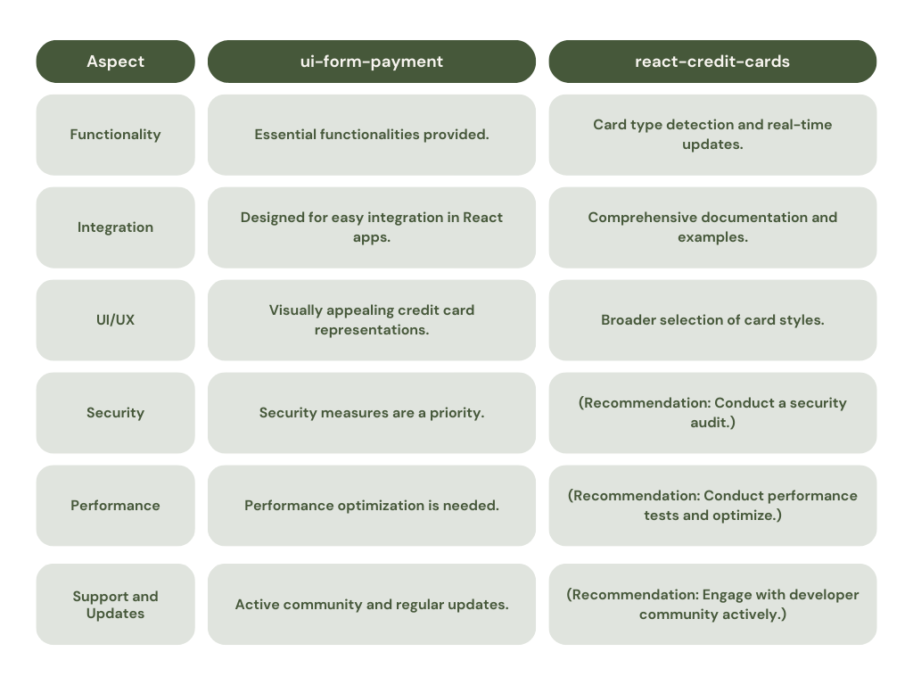
Figure 34. Comparison table of "ui-form-payment" and "react-credit-cards"

Contributions to Technology and the Field of Development
The development of the Credit Card Form Component and the study of React Component Libraries outlined in this thesis brings significant contributions to computer engineering and the field of programming. These contributions extend beyond the practical use of the library itself. They focus on the following areas:
- Code Reusability and Modularity
The creation of a reusable component library enables developers to leverage pre-built credit card form components in their projects. This promotes code reusability, reducing redundant development efforts and encouraging modular and maintainable codebases. Developers can easily integrate the library into their applications, benefiting from a well-designed and tested solution that complies with industry best practices.
- Enhanced User Experience
The Credit Card Component Library offers intuitive and user-friendly input fields, along with comprehensive validation rules. By utilizing this library, developers can ensure a smooth payment form experience for their users. The library's design promotes consistency and usability, resulting in improved user satisfaction and increased trust in the payment process.
- Standardization and Consistency
By adopting the Credit Card Form Component Library, developers can ensure consistent credit card form implementation across various applications. The library enforces standardized user interface elements and input field behaviors, reducing confusion and enhancing user familiarity. This standardization contributes to a cohesive user experience, benefiting both developers and end-users.
- Open-Source Community Engagement
The publication of your React Component Library as an open-source project actively engages the programming and developer community. By sharing your code, documentation, and examples, you facilitate knowledge sharing, encourage collaboration, and invite feedback from fellow developers. This creates an environment of learning, improvement, and community-driven innovation within the field of computer engineering.
- Educational Resource
In addition to its practical applications, this thesis and the accompanying Credit Card Form Component Library serve as valuable educational resources. Aspiring programmers and engineers seeking to learn about creating their own component libraries can refer to this work as a comprehensive guide. The documentation, methodologies, and insights provided offer a roadmap for understanding the process of developing a component library in React JS. This educational aspect adds to the overall significance and impact of this thesis.
- Efficiency and Timesaving:
By utilizing the Credit Card Form Component library, developers can save valuable development time and effort. The pre-built credit card form components can be easily integrated into their projects, reducing the need to create these components from scratch. This efficiency allows developers to focus on other critical aspects of their applications.
- Compliance with Industry Standards:
As the library meets up to industry best practices and standards for credit card processing, developers can be assured that it meets security and compliance requirements. This is particularly crucial for handling sensitive payment information securely.
- Reduced Development Errors:
The robust validation mechanisms in the library help prevent common input errors, such as incorrect credit card numbers or expiration dates. This reduces the likelihood of transaction failures and user frustration due to input mistakes.
- Flexibility and Customization:
While the library provides ready-to-use components, it also offers flexibility for customization. Developers can tailor the components to align with their specific design and branding preferences, maintaining a consistent look and feel across their applications.

- Community-Driven Improvement:
As an open-source library, this project benefits from the contributions and feedback of the developer community. Users can report issues, suggest improvements, and even contribute code enhancements, fostering a collaborative environment and continuously improving the library's functionality.
- Future-Ready Features:
The credit card component library's planned updates, such as credit card validation and integration with payment gateways, demonstrate the commitment to staying up-to-date with evolving payment technologies. Developers can rely on the library to provide cutting-edge features that align with the latest industry trends.
- Cost-Effectiveness:
Since the library is open-source and freely available on npm packages, it provides a cost-effective solution for developers and businesses seeking to implement secure credit card processing in their applications without the need for expensive third-party solutions.
The contributions outlined above demonstrate the relevance and importance of the Credit Card Form Component Library project within the broader context of computer engineering and programming. The library's practical applications, standardization efforts, community engagement, and educational value collectively contribute to the advancement and growth of the field.
The repository of the component created is found at GitHub, whereas the package is available on npm packages.

CHAPTER 5

CONCLUSION

Summary of findings
In conclusion, this thesis has explored the development and implications of the Credit Card Form Component Library and its associated React Component Library. The findings from this study, along with the broader context of React as a front-end web development framework, can be summarized as follows:
React has emerged as one of the most popular frameworks/libraries for front-end web development, offering user-friendly nature, flexibility, and a large community. The comparative analysis with other frameworks highlighted React's unique strengths, such as its virtual DOM and component-based architecture, which sets it apart from its peers. These features make React well-suited for the increasing demand of reusable and modular components in the rapidly evolving landscape of web applications. Creating a React component library is a challenging but valuable undertaking. Once published, a well-designed library can be readily shared with fellow developers, promoting code reusability and saving time and effort in future projects. This fosters collaboration and contributes to the overall growth and of the community of React.
The development and publication of the Credit Card Form Component Library specifically have brought significant contributions to the field of computer engineering and programming, extending beyond the immediate practical use of the library itself. These contributions encompass code reusability and modularity, enhanced user experience, standardization and consistency, open-source community engagement, and serving as an educational resource.

Future Work and Recommendations
Building upon the findings and contributions of this study, there are several avenues for future work and recommendations:
- Continuously enhancing and expanding the Credit Card Form Component Library with additional features, customization options, and compatibility with various payment gateways to cater to evolving user needs.
- Conducting rigorous user testing and obtaining feedback to iterate and further improve the library's user interface and overall user experience.
- Investing in accessibility features to ensure inclusivity and compliance with web accessibility standards, making the library accessible to users with diverse needs.
- Conducting performance evaluations and optimization techniques to improve the library's efficiency and responsiveness, enabling smooth performance even in resource-constrained environments.
- Exploring opportunities for integrating the Credit Card Form Component Library with popular frontend frameworks and libraries, broadening its compatibility and increasing its adoption among developers.
By pursuing these recommendations, future research and development efforts can build upon the findings of this thesis, further advancing the field of computer engineering and programming while contributing to the React ecosystem.

REFERENCES
[1] | React Documentation. (2023, April 16). Learn React. https://react.dev/learn
[2] | React Documentation. (2023, April 16). Manipulating the DOM with refs. https://react.dev/learn/manipulating-the-dom-with-refs
[3] | STATISTA. (2022). Worldwide developer survey: Most used frameworks/web technologies as of 2022. https://www.statista.com/statistics/1124699/worldwide-developer-survey-most-used-frameworks-web/#:~:text=js%20overtook%20React.,42.62%20percent%20were%20using%20React
[4] | Wikipedia contributors. (2023, April 14). React (software). In Wikipedia, The Free Encyclopedia. Retrieved April 16, 2023, from https://en.wikipedia.org/w/index.php?title=React_(software)&amp;oldid=1149788815
[5] | Naim, N. I. (2017). ReactJS: An Open Source JavaScript Library for Front-end Development. Bachelor of Engineering Information Technology Thesis, Metropolia University of Applied Sciences.
[6] | Naim, N. I. (2017). ReactJS: An Open Source JavaScript Library for Front-end Development. Bachelor of Engineering Information Technology Thesis, Metropolia University of Applied Sciences.
[7] | Largest companies adopting React: Revenue and number of employees. (2022, February 12). Career Karma. https://careerkarma.com/blog/companies-that-use-react/
[8] | Tielitz, A. (2016). Automatically extracting view models from component-based web applications (Doctoral dissertation, Technische Universität München). DEPARTMENT OF INFORMATI5CS.
[9] | Wikipedia contributors. (2023, May 10). Figma (software). In Wikipedia, The Free Encyclopedia. Retrieved 07:43, May 18, 2023, from https://en.wikipedia.org/w/index.php?title=Figma_(software)&oldid=1154131340
[10] | npm. (May 17, 2023). rollup-plugin-postcss. https://www.npmjs.com/package/rollup-plugin-postcss
[11] | npm. (2023 May 17, 2023). @rollup/plugin-url https://www.npmjs.com/package/@rollup/plugin-url
[12] | Semantic Versioning. (2023, May 17). https://semver.org/
[13] | React Testing. (2023, May 17) https://legacy.reactjs.org/docs/testing.html#:~:text=There%20are%20a%20few%20ways,to%2Dend%E2%80%9D%20tests.
[14] | Jest (2023, May 17) https://jestjs.io/
[15] | Testing Library (2023, May 17) React Testing Library - Introduction. https://testing-library.com/docs/react-testing-library/intro/
[16] | Enzyme. (2023, May 17). from https://enzymejs.github.io/enzyme/
[17] | npm. (2023 May, 17). jest-environment-jsdom. https://npm.io/package/jest-environment-jsdom
[18] | Babel. (2023 May, 17.), from https://babeljs.io/docs
[19] | MDN Web Docs. (2023 May, 27.),. Proxy, from https://developer.mozilla.org/en-US/docs/Web/JavaScript/Reference/Global_Objects/Proxy
[20] | Jest. (2023 May, 27) Configuration, from https://jestjs.io/docs/configuration
[21] | Storybook. (2023 May, 27), from https://storybook.js.org/
[22] | npm. (2023 May, 27). npm-init, from https://docs.npmjs.com/cli/v7/commands/npm-init
[23] | npm. (2023 May, 27). @types/react, from https://www.npmjs.com/package/@types/react
[24] | npm. (2023, May 27). tsc-init. Retrieved May 27, 2023, from https://www.npmjs.com/package/tsc-init
[25] | npm. (2023, May 27). rollup. Retrieved May 17, 2023, from https://www.npmjs.com/package/rollup
[26] | npm. (2023, May 27). @rollup/plugin-node-resolve. Retrieved May 17, 2023, from https://www.npmjs.com/package/@rollup/plugin-node-resolve
[27] | npm. (2023, May 27). @rollup/plugin-commonjs. Retrieved May 17, 2023, from https://www.npmjs.com/package/@rollup/plugin-commonjs
[28] | npm. (2023, May 27). rollup-plugin-dts. Retrieved May 17, 2023, from https://www.npmjs.com/package/rollup-plugin-dts
[29] | npm. (June 4, 2023). Retrieved June 4, 2023, from https://www.npmjs.com/
[30] | npm. (June 4, 2023) Creating and publishing scoped public packages. Retrieved June 4, 2023, from https://docs.npmjs.com/creating-and-publishing-scoped-public-packages
[31] | npm. (2023 July, 21.). react-credit-cards, from https://www.npmjs.com/package/react-credit-cards
[32] | Kajana Martina (4 June, 2023). Retrive 4 June 2023 from https://github.com/mkajana/ui-form-payment
[33] | Kajana Martina (4 June, 2023). Retrive 4 June 2023 from https://www.npmjs.com/package/@mkajana/ui-form-payment

APPENDIX A
React Component Library Template
Folder structure:
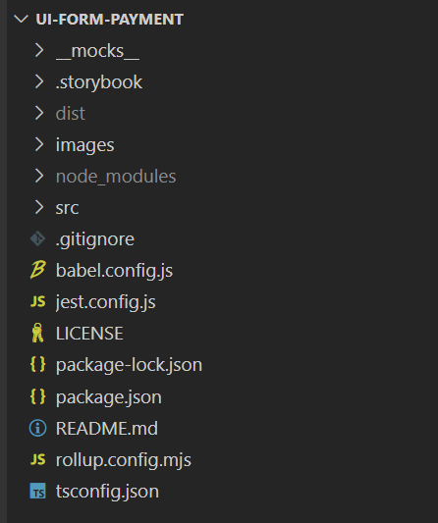
Figure 35. Folder Structure of ui-form-payment library, the component library developed through this thesis.
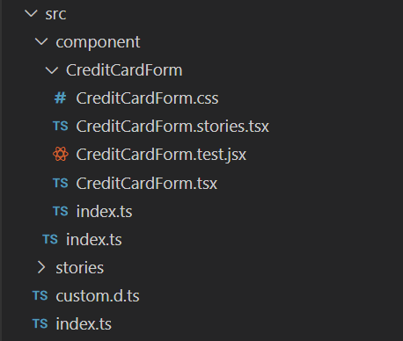
Figure 36. Structure of the source directory in the ui-form-payment library, where the component is located.

Component structure:

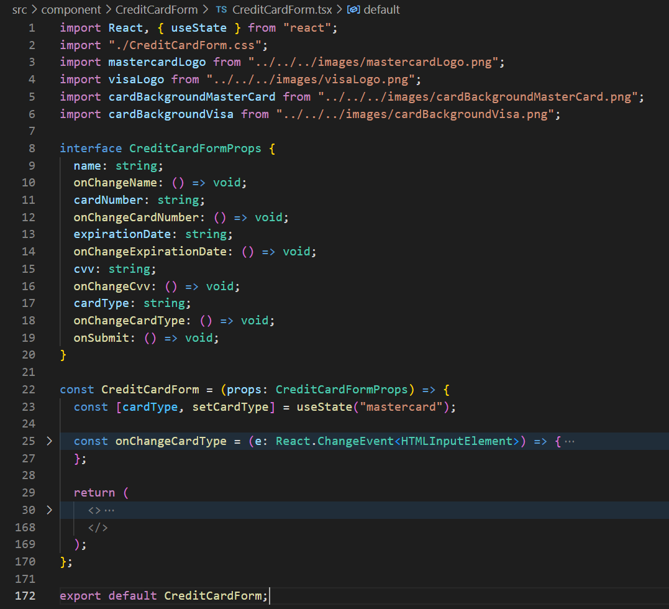
Figure 37. React Credit Card Form component with dynamic card type selection and input fields for card details. It includes the imports, then the props of the interface of the CreditCardForm and the default function of the component. The default function has options to select the card type and it returns the JSX code for the UI of the credit card component.

Configuration files: package.json, webpack.config.js, babel.config.js, etc.

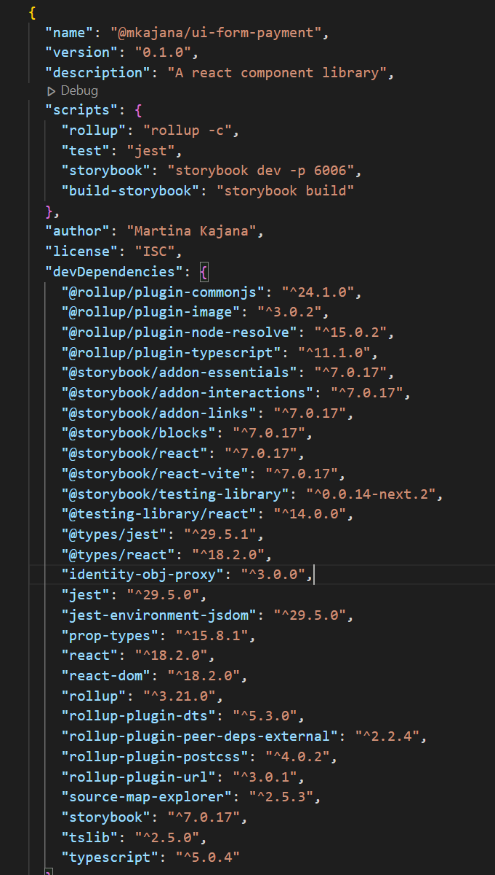
Figure 38. Package.json configuration for the @mkajana/ui-form-payment library. It includes dependencies, dev dependencies, and scripts for Rollup, Jest, and Storybook. The library provides a collection of React components for payment forms, first part.
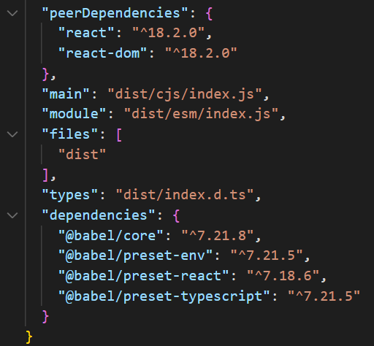
Figure 39. Package.json configuration for the @mkajana/ui-form-payment library. It includes dependencies, dev dependencies, and scripts for Rollup, Jest, and Storybook. The library provides a collection of React components for payment forms, second part

Read Me file:
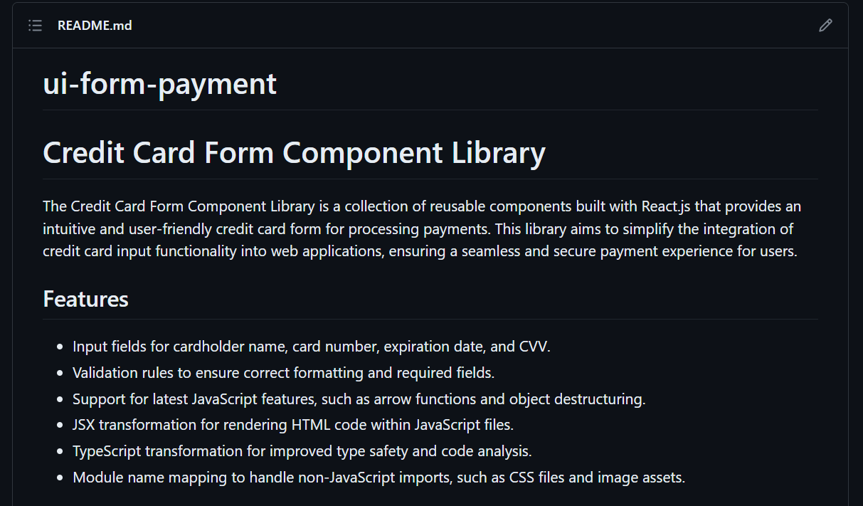
Figure 40. Screenshot of the Read Me file of the credit card form component library, introducing the component and its features.

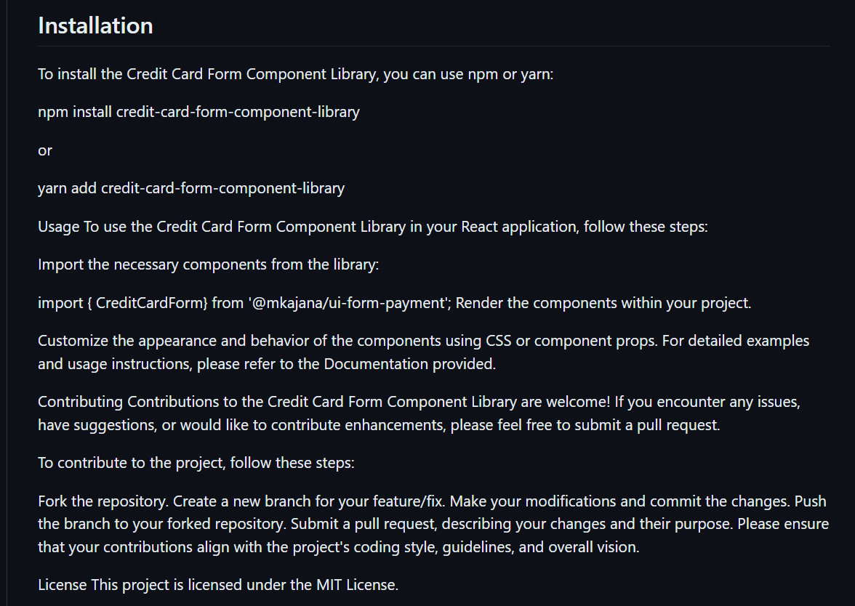
Figure 41. Screenshot of the Read Me file of the credit card form component library, introducing the guide for the installation.

APPENDIX B
Test Files
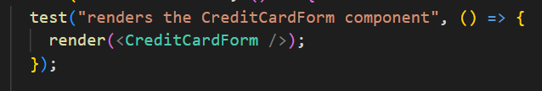
Figure 42. First test:"renders the CreditCardForm component", verifies if the component renders without throwing any errors. It uses the render function from the testing library to render the CreditCardForm component.
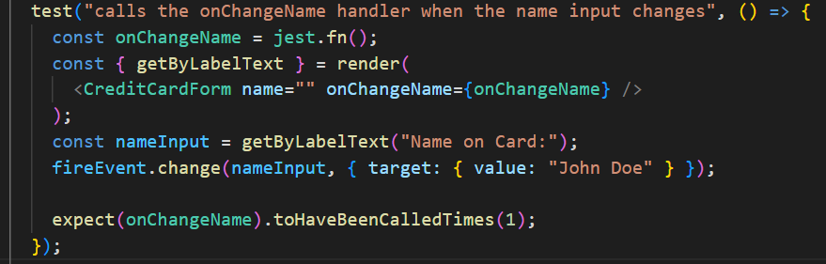
Figure 43 Second test: "calls the onChangeName handler when the name input changes", ensures that the onChangeName handler is called when the name input field is changed. It sets up a mock function onChangeName using jest.fn(), renders the CreditCardForm component
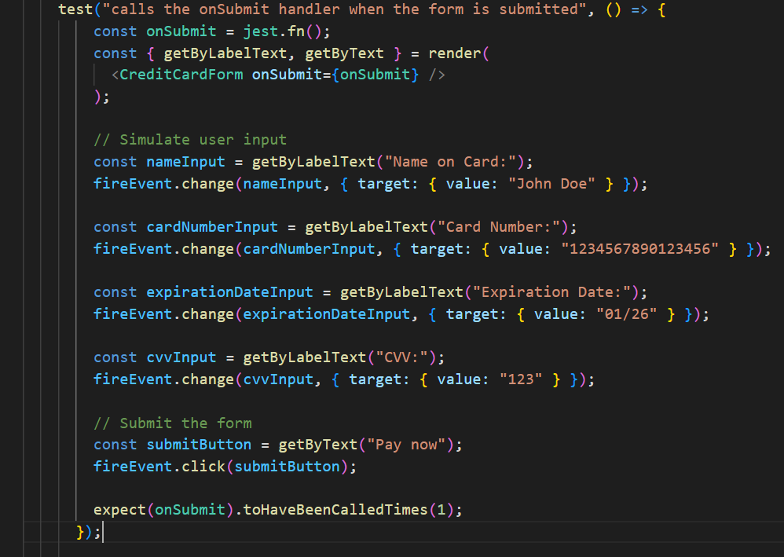
Figure 44. Third test: Test to verify that the onSubmit handler is called when the form is submitted with valid input in the CreditCardForm component.
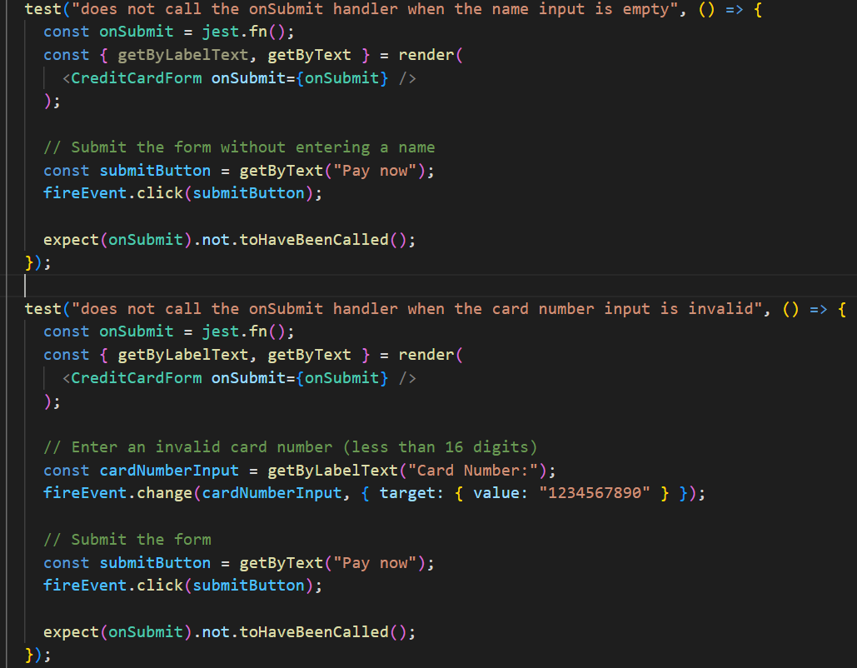
Figure 45. Two test files: Test to ensure that the onSubmit handler is not called when the name input is empty in the CreditCardForm component, and "Validation test to confirm that the onSubmit handler is not called when an invalid card number input (less than 16
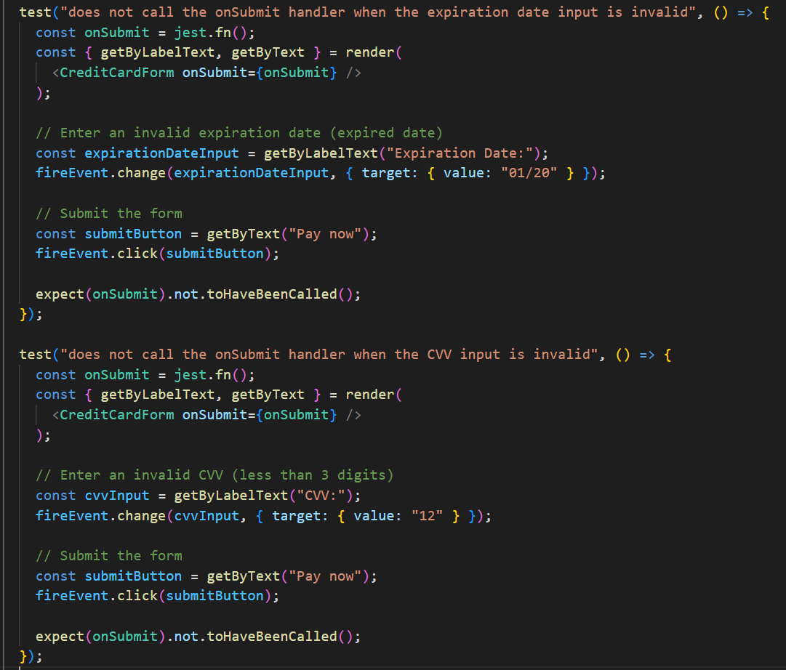
Figure 46 Two test files: "Validation test to ensure that the onSubmit handler is not called when an invalid expiration date (expired date) is entered in the CreditCardForm component." And "Test to verify that the onSubmit handler is not called when an invalid CVV (less than 3 digits) is provided in the CreditCardForm component."
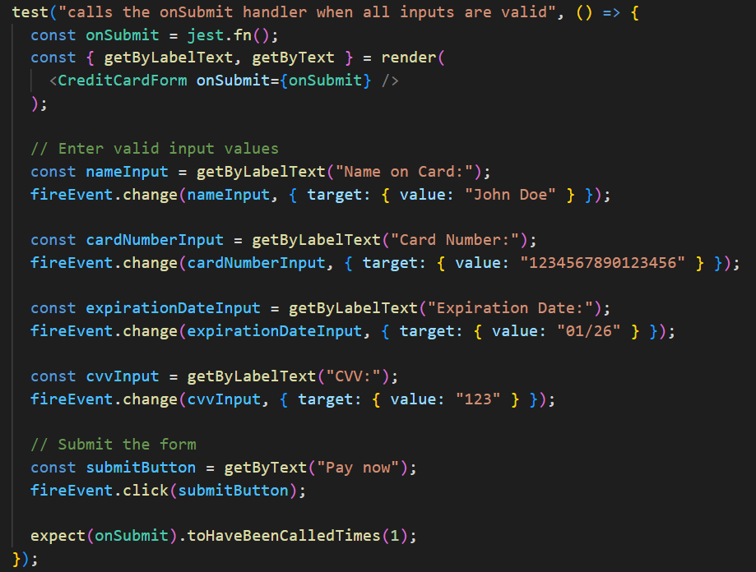
Figure 47. Test to ensure that the onSubmit handler is called when all input fields contain valid values in the CreditCardForm component.

React Documentation. (2023, April 16). Learn React. https://react.dev/learn
React Documentation. (2023, April 16). Manipulating the DOM with refs. https://react.dev/learn/manipulating-the-dom-with-refs
STATISTA, 2022 published, 16/04/2023 last viewed, https://www.statista.com/statistics/1124699/worldwide-developer-survey-most-used-frameworks-web/#:~:text=js%20overtook%20React.,42.62%20percent%20were%20using%20React
Wikipedia contributors. (2023, April 14). React (software). In Wikipedia, The Free Encyclopedia. Retrieved 18:10, April 16, 2023, from https://en.wikipedia.org/w/index.php?title=React_(software)&oldid=1149788815
Naimul Islam Naim, ReactJS: An Open Source JavaScript Library for Front-end Development: Metropolia University of Applied Sciences Bachelor of Engineering Information Technology Thesis ,30 May 2017
Naimul Islam Naim, ReactJS: An Open Source JavaScript Library for Front-end Development: Metropolia University of Applied Sciences Bachelor of Engineering Information Technology Thesis ,30 May 2017
Largest companies adopting React: Revenue and number of employees, February 12 2022, https://careerkarma.com/blog/companies-that-use-react/, last visited 17/04/2023
Tielitz, A. (2016). Automatically extracting view models from component-based web applications (Doctoral dissertation, Technische Universität München). DEPARTMENT OF INFORMATICS.
Wikipedia contributors. (2023, April 16). Figma (software). In Wikipedia, The Free Encyclopedia. Retrieved 13:33, May 7, 2023, from https://en.wikipedia.org/w/index.php?title=Figma_(software)&oldid=1150207867
npm. (May 17, 2023). rollup-plugin-postcss. https://www.npmjs.com/package/rollup-plugin-postcss
npm. (2023 May 17, 2023). @rollup/plugin-url https://www.npmjs.com/package/@rollup/plugin-url
Semantic Versioning. (2023, May 17). https://semver.org/
React Testing. (2023, May 17) https://legacy.reactjs.org/docs/testing.html#:~:text=There%20are%20a%20few%20ways,to%2Dend%E2%80%9D%20tests.
Jest (2023, May 17) https://jestjs.io/
Testing Library (2023, May 17) React Testing Library - Introduction. https://testing-library.com/docs/react-testing-library/intro/
Enzyme. (2023, May 17). from https://enzymejs.github.io/enzyme/
npm. (2023 May, 17). jest-environment-jsdom. https://npm.io/package/jest-environment-jsdom
Babel. (2023 May, 17.), from https://babeljs.io/docs
MDN Web Docs. (2023 May, 27.),. Proxy, from https://developer.mozilla.org/en-US/docs/Web/JavaScript/Reference/Global_Objects/Proxy
Jest. (2023 May, 27) Configuration, from https://jestjs.io/docs/configuration
Storybook. (2023 May, 27), from https://storybook.js.org/
npm. (2023 May, 27). npm-init, from https://docs.npmjs.com/cli/v7/commands/npm-init
npm. (2023 May, 27). @types/react, from https://www.npmjs.com/package/@types/react
npm. (2023, May 27). tsc-init. Retrieved May 27, 2023, from https://www.npmjs.com/package/tsc-init
npm. (2023, May 27). rollup. Retrieved May 17, 2023, from https://www.npmjs.com/package/rollup
npm. (2023, May 27). @rollup/plugin-node-resolve. Retrieved May 17, 2023, from https://www.npmjs.com/package/@rollup/plugin-node-resolve
npm. (2023, May 27). @rollup/plugin-commonjs. Retrieved May 17, 2023, from https://www.npmjs.com/package/@rollup/plugin-commonjs
npm. (2023, May 27). rollup-plugin-dts. Retrieved May 17, 2023, from https://www.npmjs.com/package/rollup-plugin-dts
npm. (June 4, 2023). Retrieved June 4, 2023, from https://www.npmjs.com/
npm. (June 4, 2023) Creating and publishing scoped public packages. Retrieved June 4, 2023, from https://docs.npmjs.com/creating-and-publishing-scoped-public-packages
npm. (2023 July, 21.). react-credit-cards, from https://www.npmjs.com/package/react-credit-cards
Kajana Martina (4 June, 2023). Retrive 4 June 2023 from https://github.com/mkajana/ui-form-payment
Kajana Martina (4 June, 2023). Retrive 4 June 2023 from https://www.npmjs.com/package/@mkajana/ui-form-payment

